**Route 53 – Private Hosted Zone Lab**

**Scenario:**

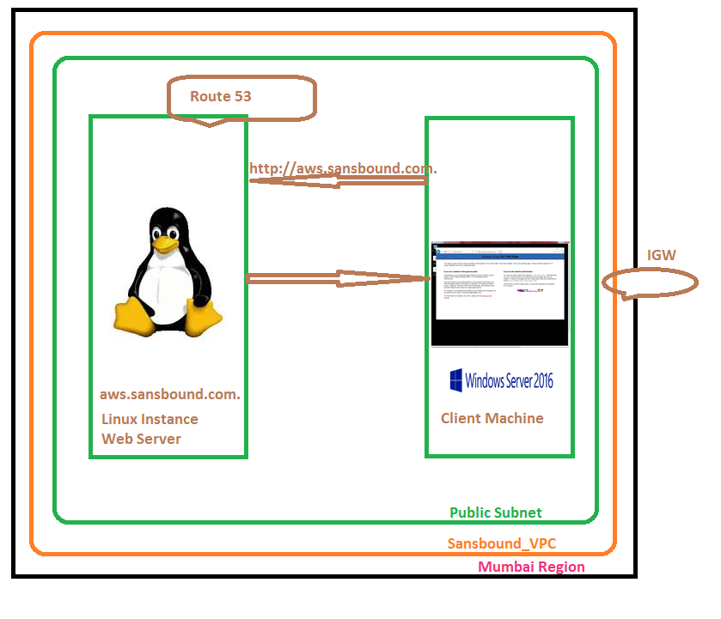

We have created Sansbound_VPC in Mumbai region, in sansbound subnet we have created public subnet and created one Linux instance and one Windows windows instance. In Linux instance we need to install the web server and in windows machine we need to access the web server by using IP address and FQDN (Fully Qualified Domain Name).

We are in Mumbai region, we need to create one VPC.

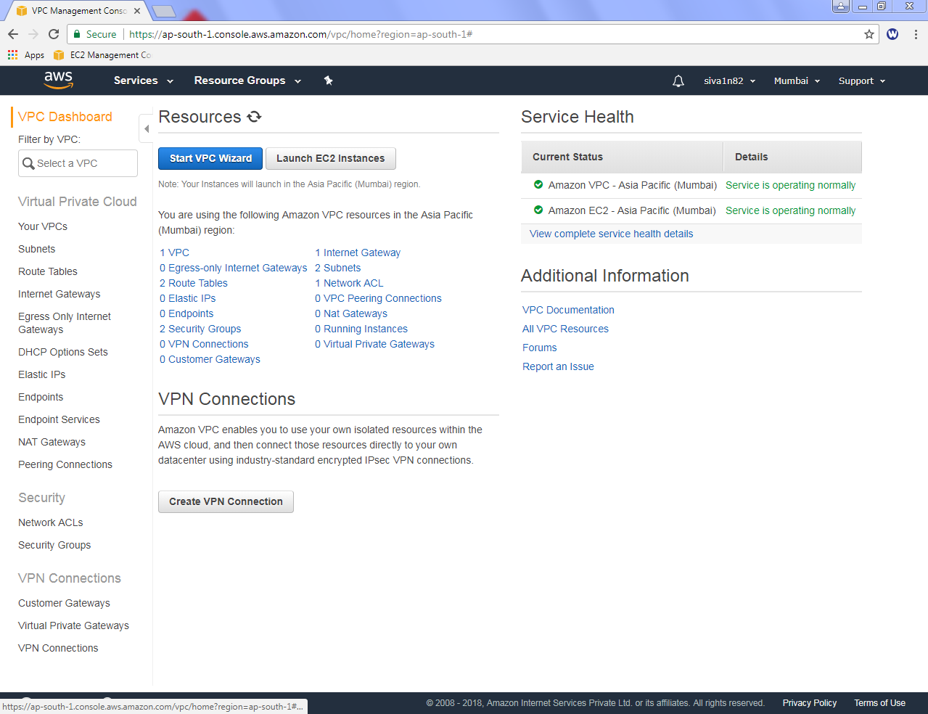

In VPC Dashboard, click “Create VPC”.

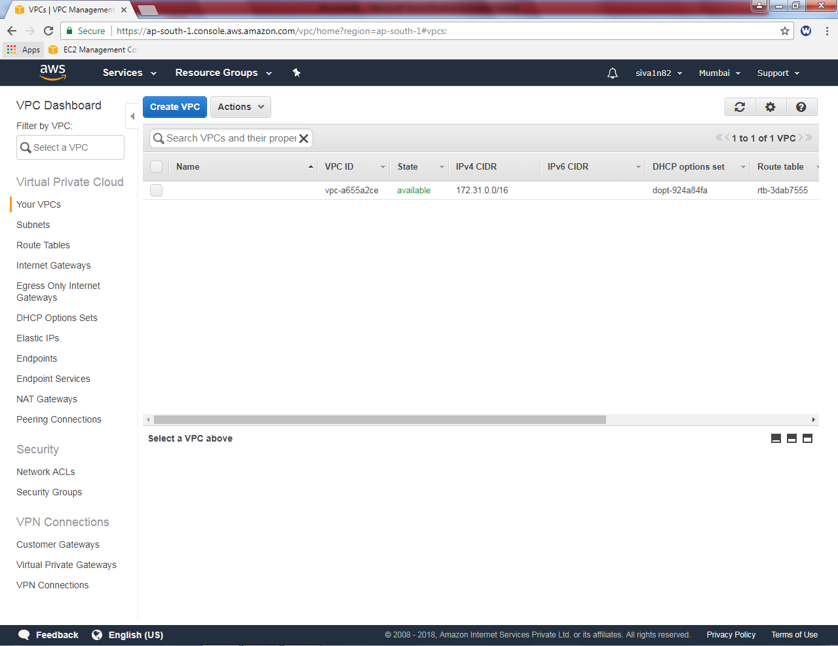

While creating VPC,

Name tag “Sansbound_VPC”

IPV4 CIDR block “10.0.0.0/16”

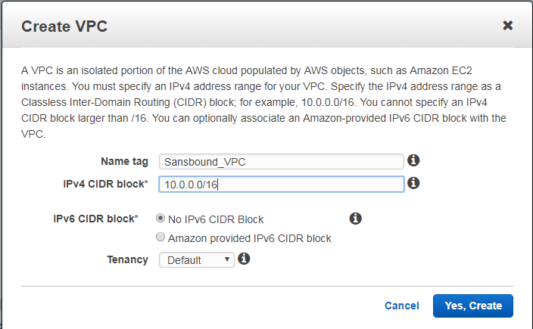

Click “Yes, create”.

Then we need to create subnet,

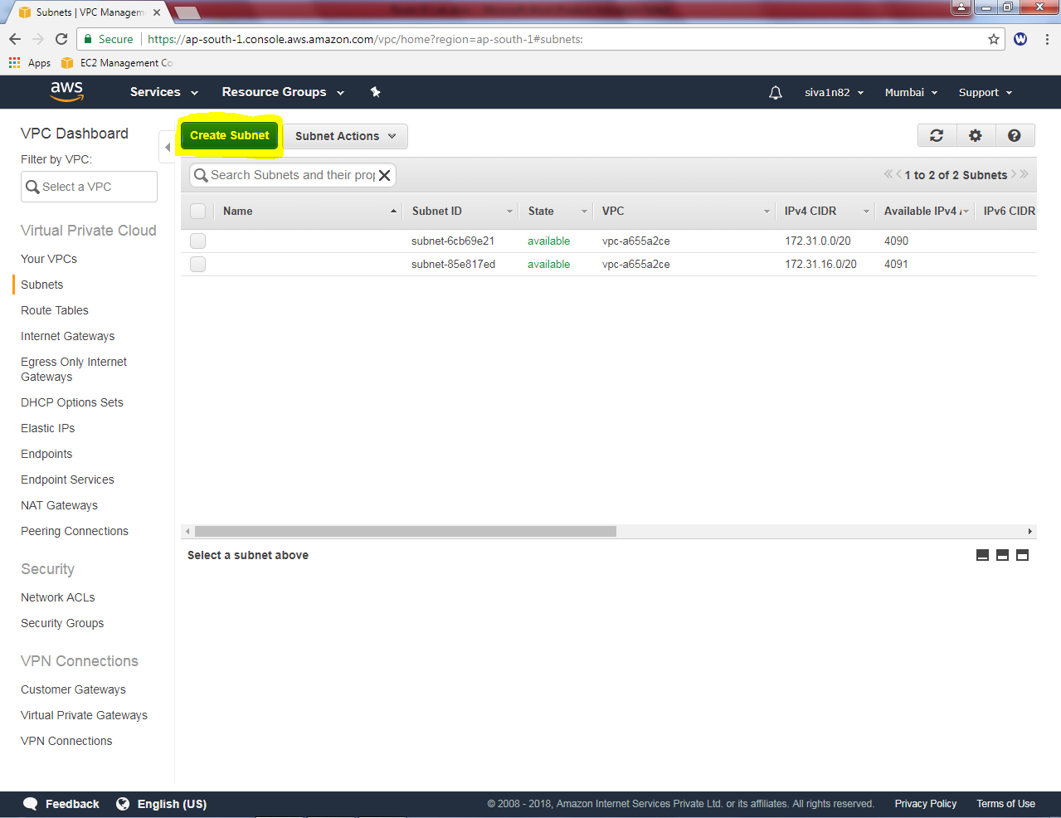

Click “Create subnet”.

While creating subnet,

Name tag: “sansbound_public_subnet”

VPC as “Sansbound_VPC”

Availability Zone : 1B (Optional)

IPV4 CIDR Block 10.0.2.0/24 subnet

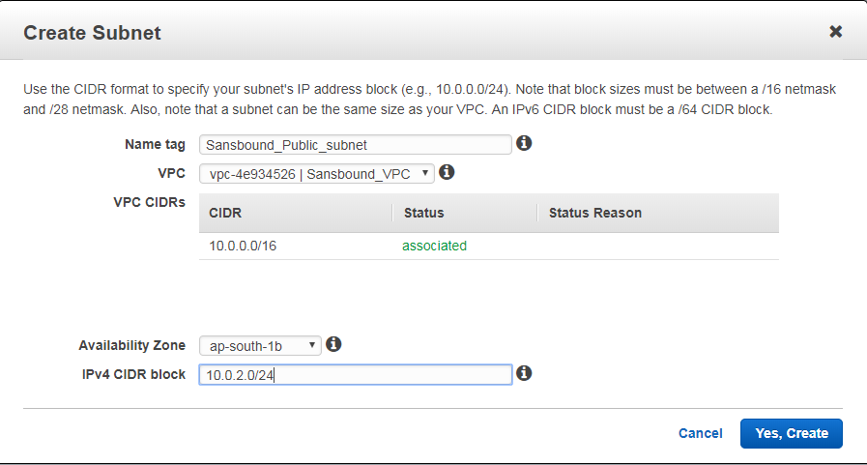

Then click “Yes, create”.

Now, we need to create an Internet Gateway.

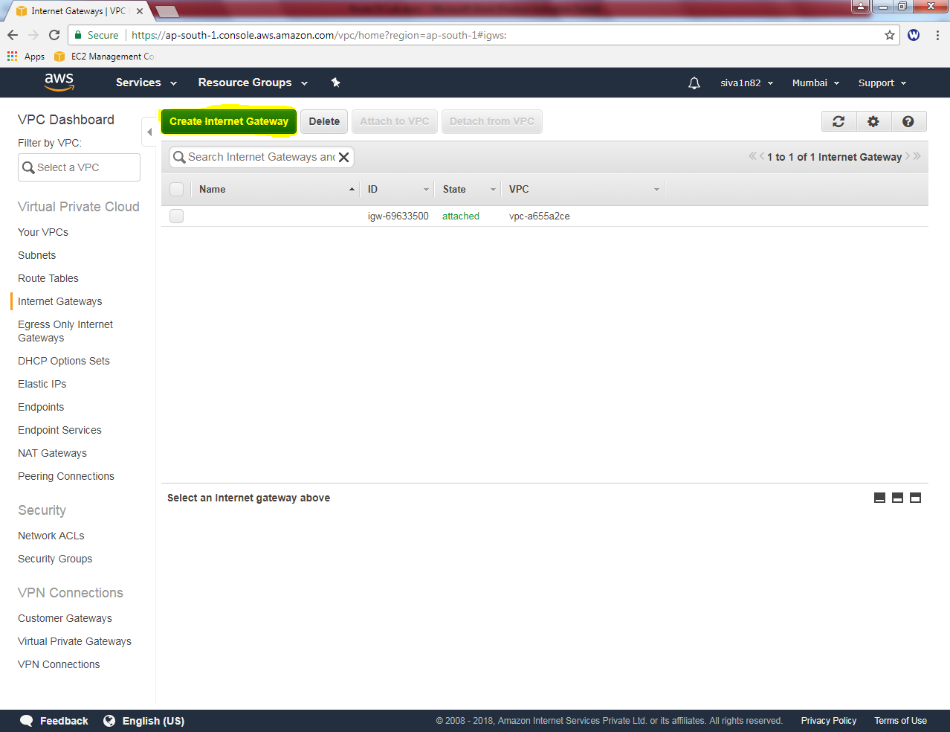

Click “Create Internet Gateway”.

While creating Internet Gateway, name tag as “sansbound_IGW”.

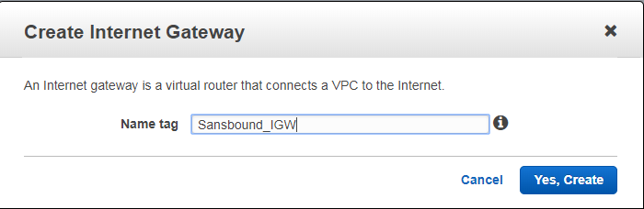

Click “Yes, Create”.

In Internet gateway, Sansbound_IGW is in detached mode. We need to attach VPC (Sansbound_VPC) with Internet gateway. Click “Attach to VPC”.

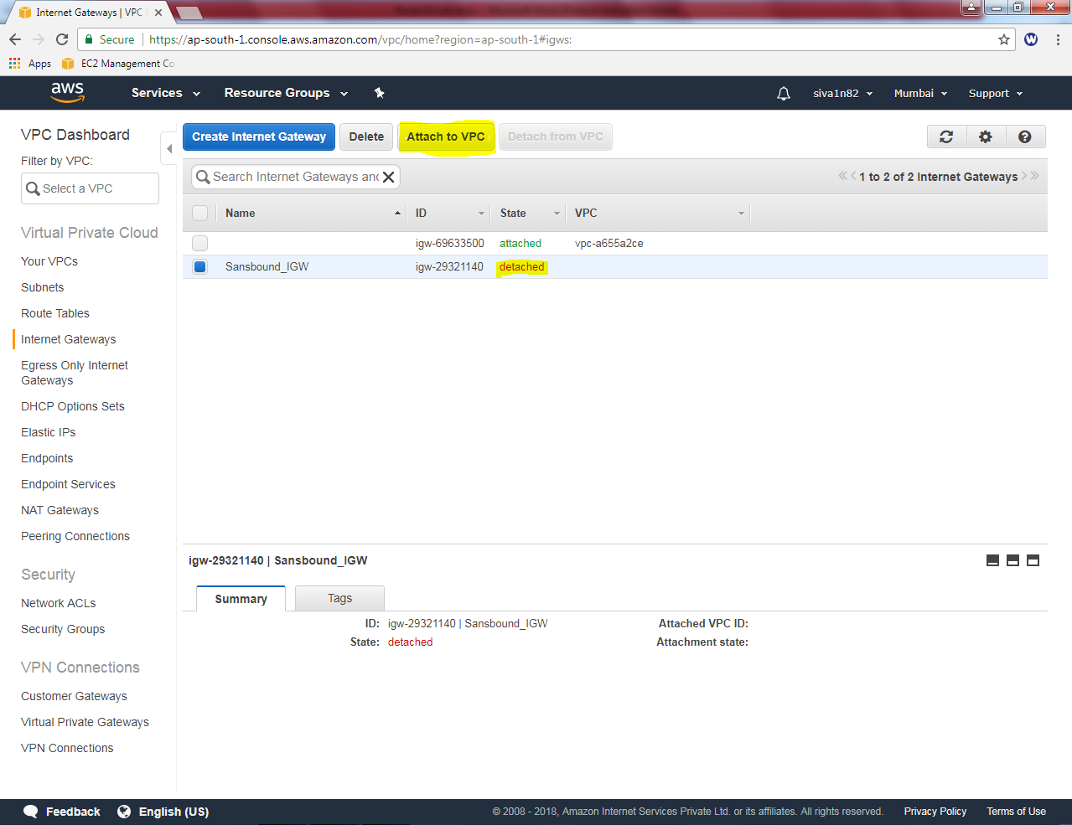

Click “Yes, Attach”.

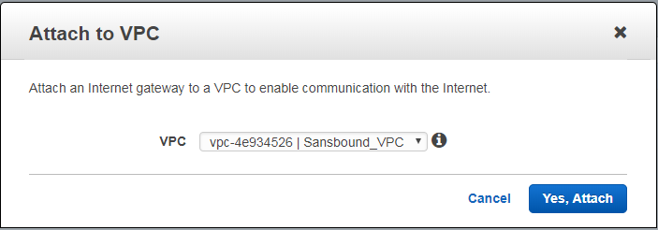

In Sansbound_VPC route table, rename as sansbound_public_route.

Then select Route tab, click “Edit”.

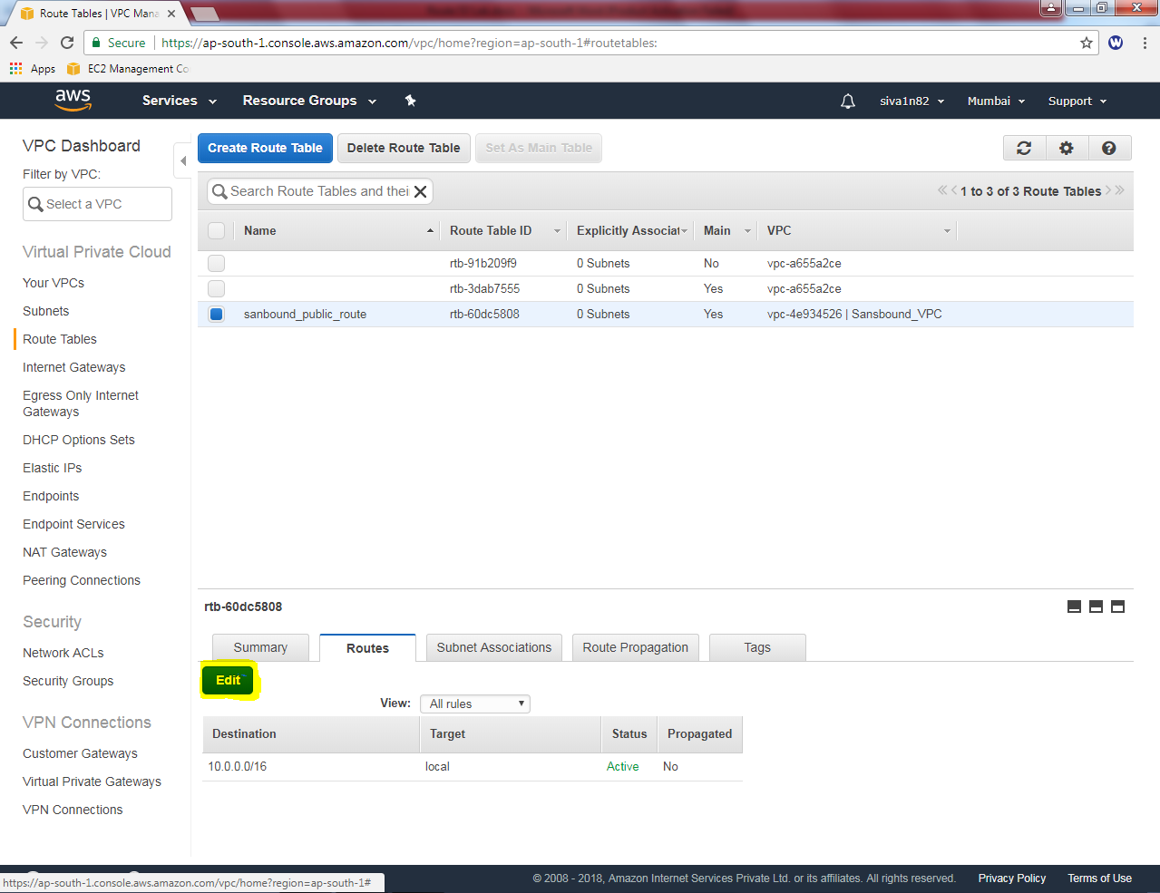

Click “Add another route”

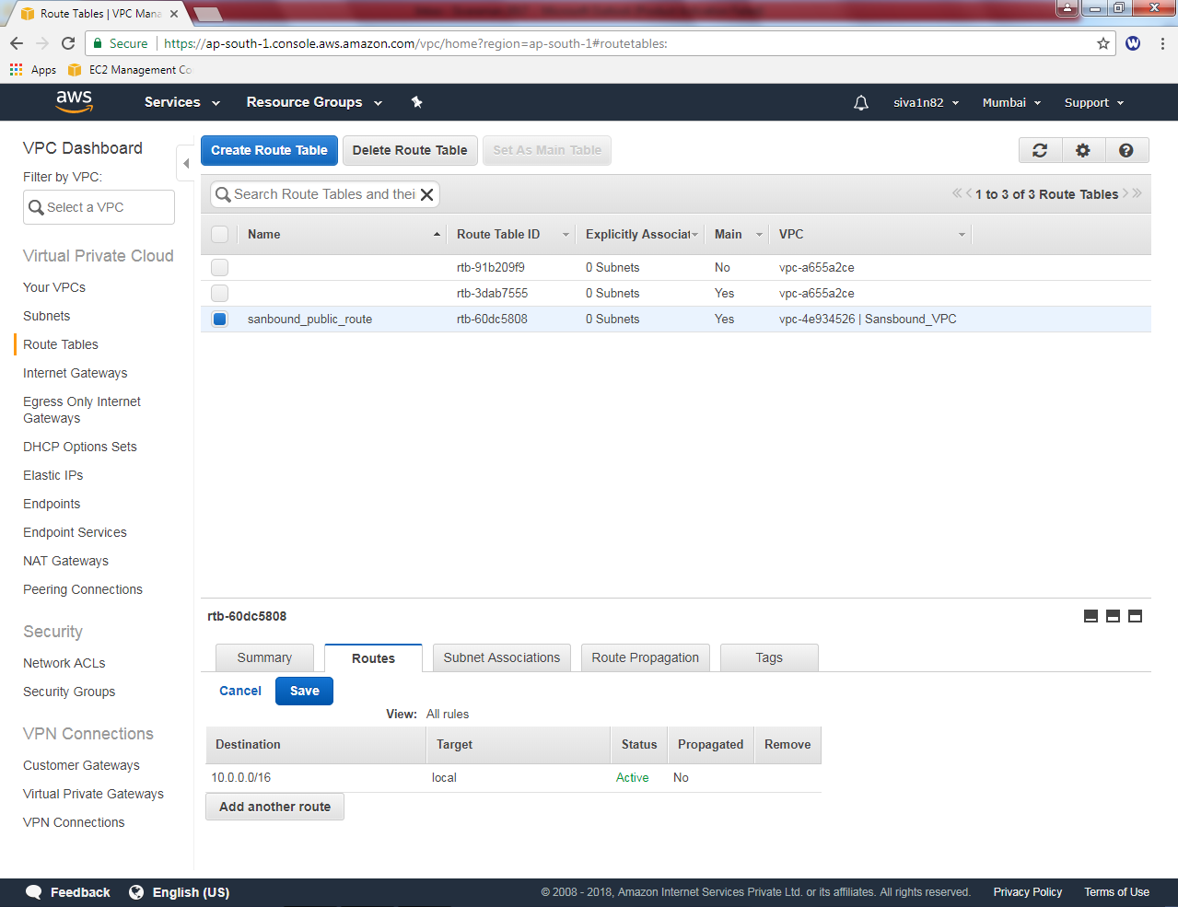

Add default route 0.0.0.0/0 in sansbound_public_route table and select target as “igw-*”.

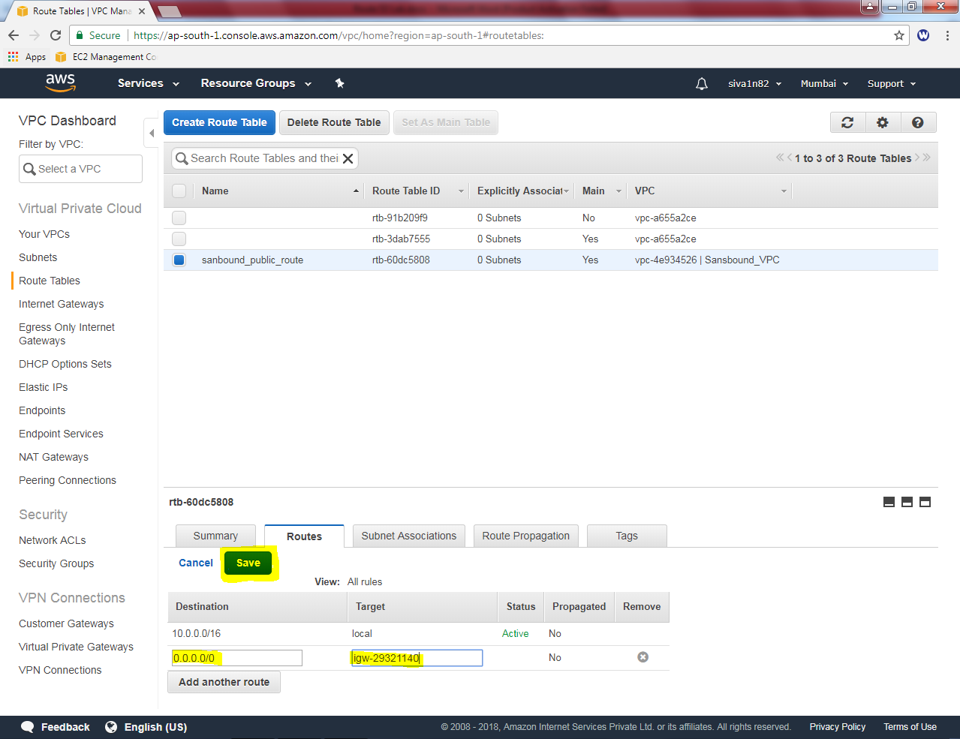

Then click “Save”.

In Subnet associations tab, click “Edit” option.

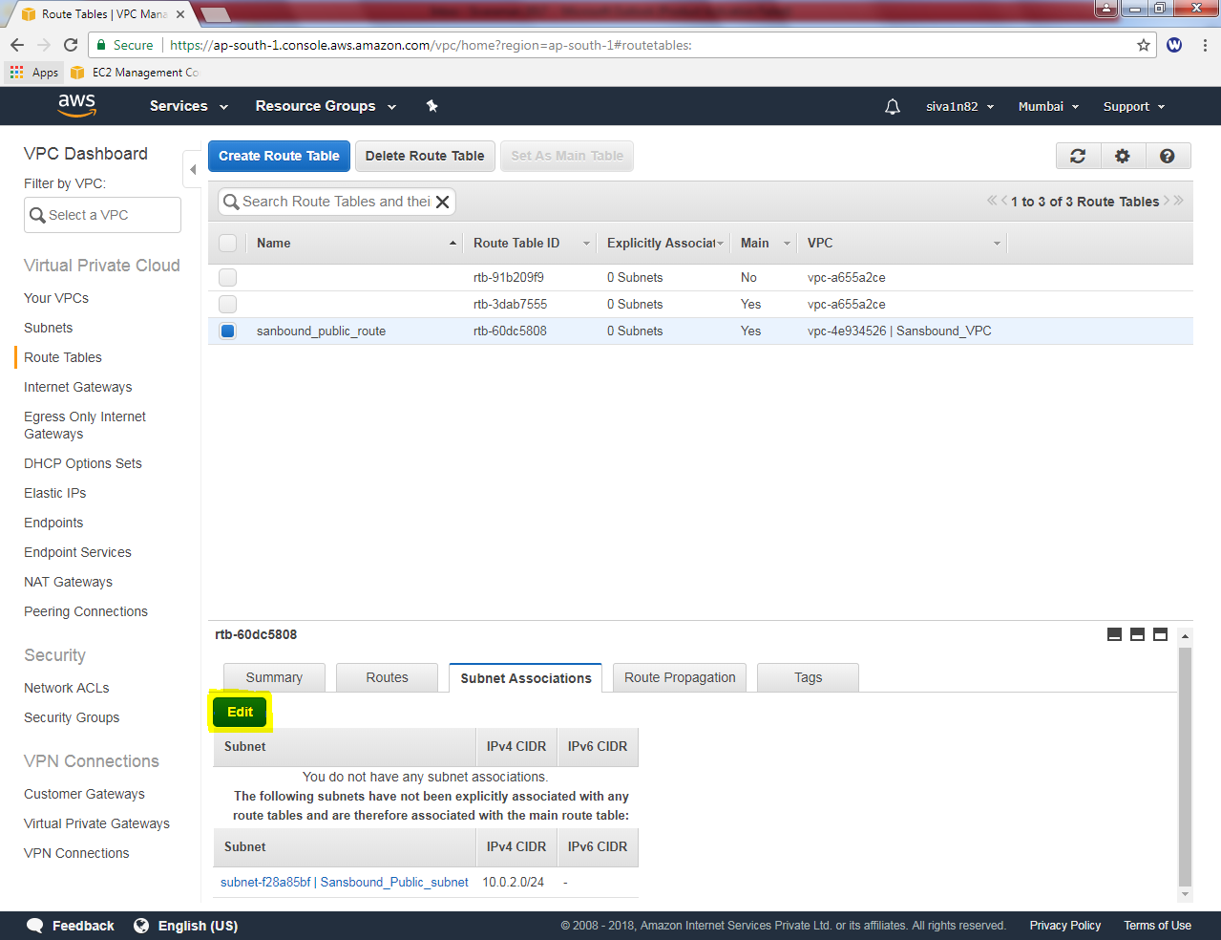

Select “Sansbound_Public_Subnet”check box and click “save”.

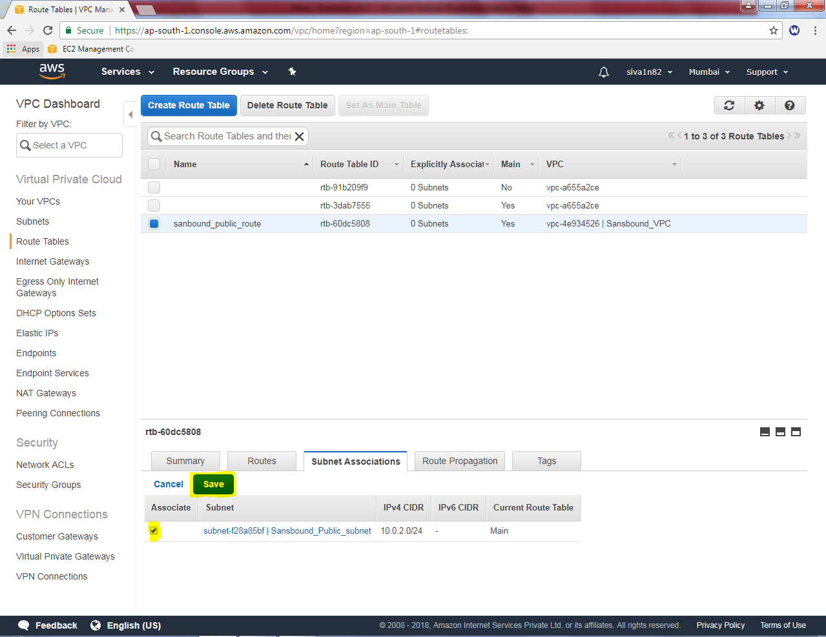

Now we need to create two instances.

Goto EC2, click launch instance

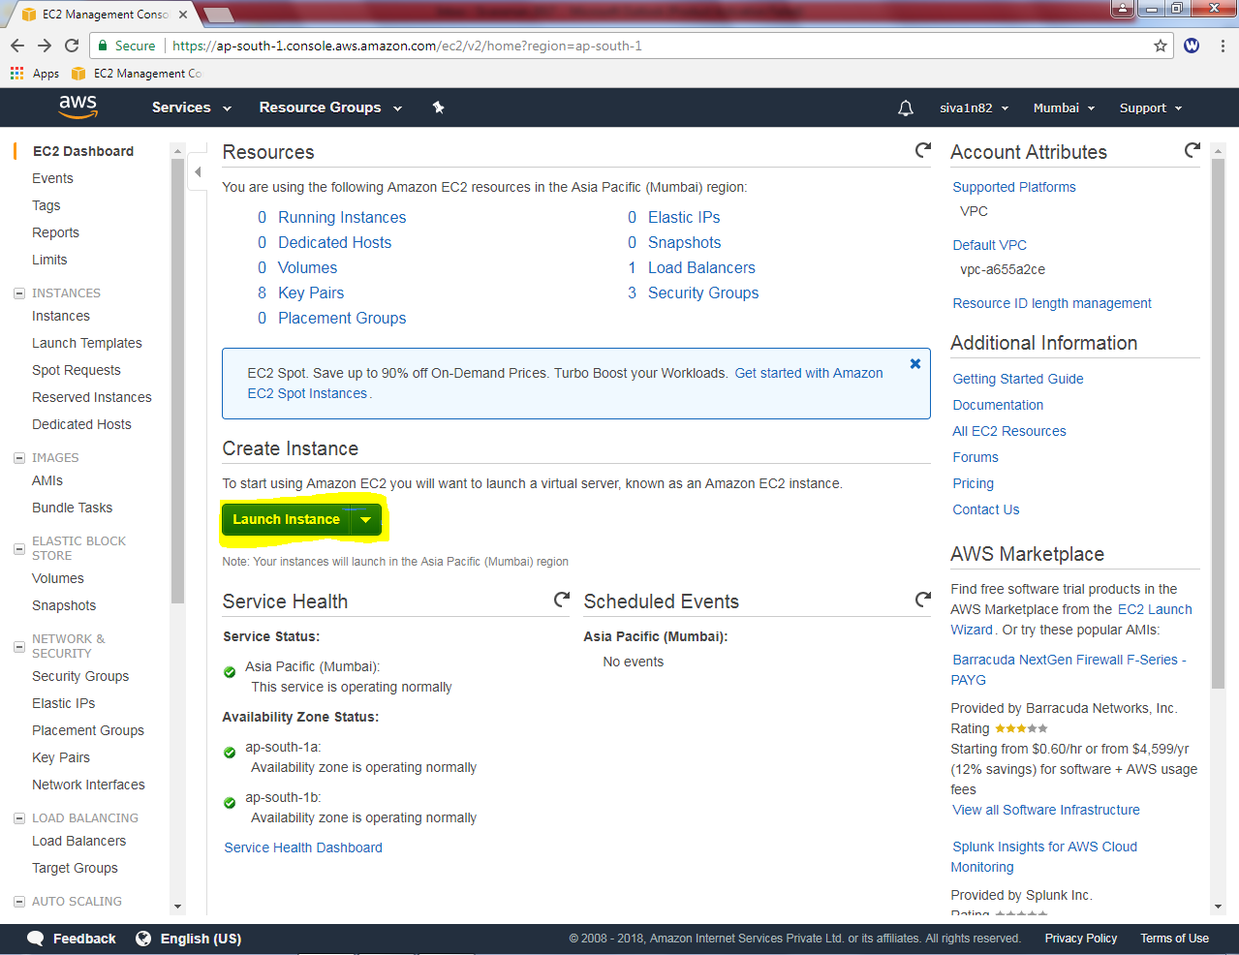

Select Amazon Linux AMI and then click Next

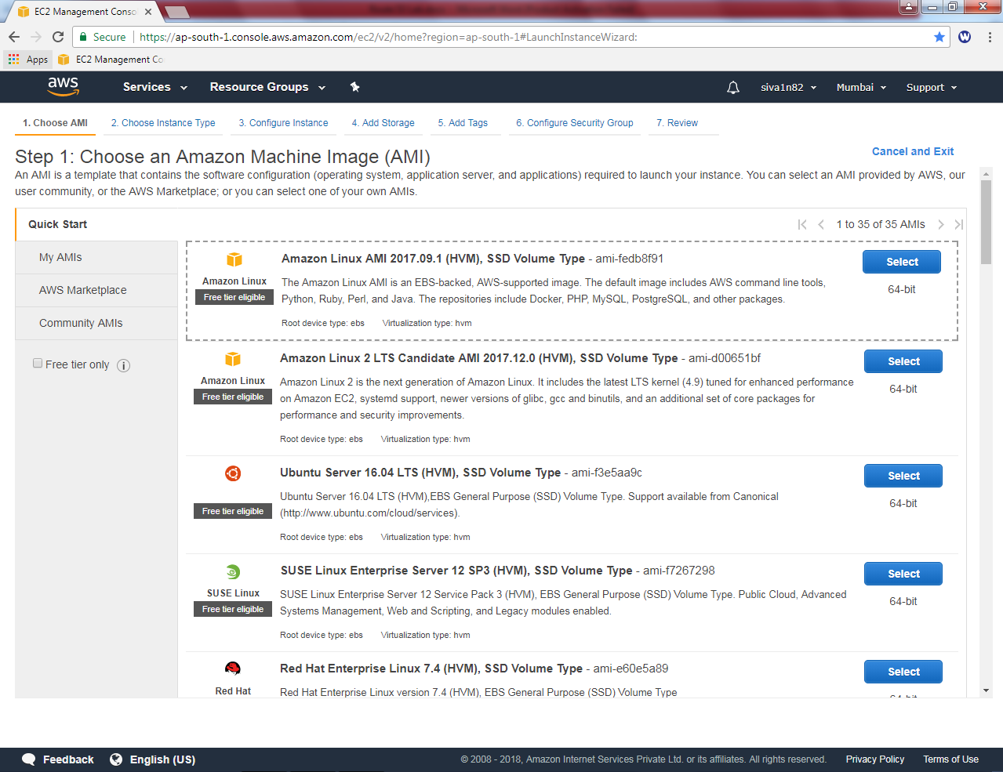

Select “General purpose” – t2.micro

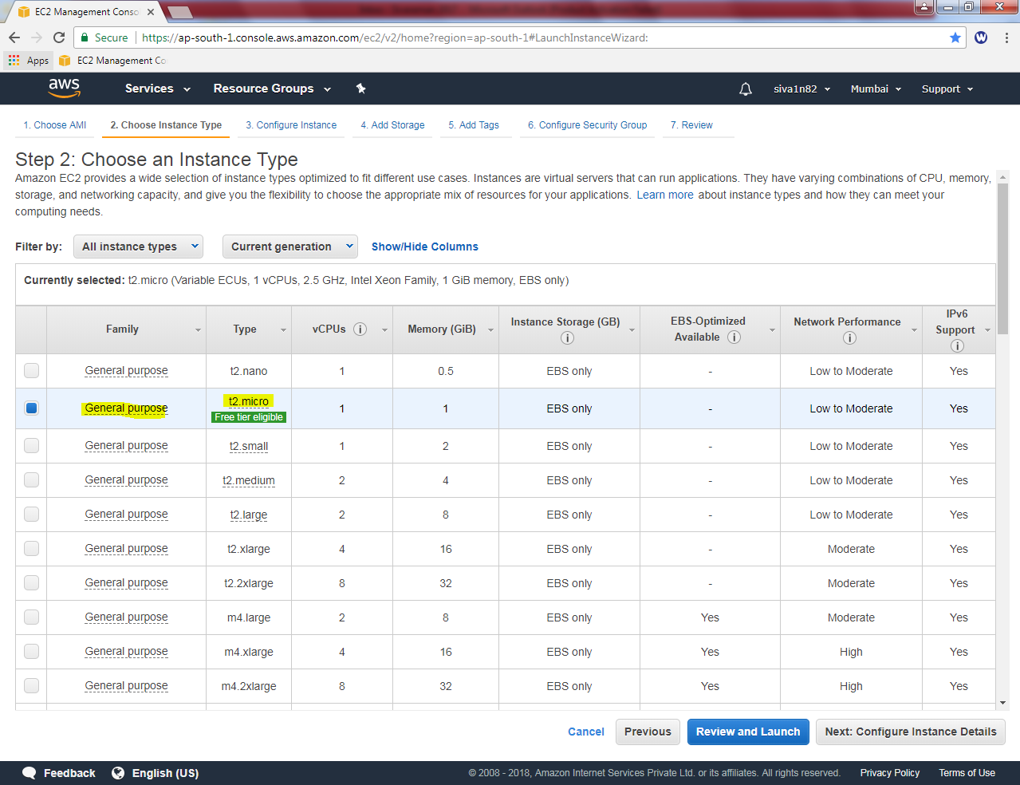

Network : Sansbound_VPC

Subnet : Public_Subnet

Auto assign Public IP: Enable

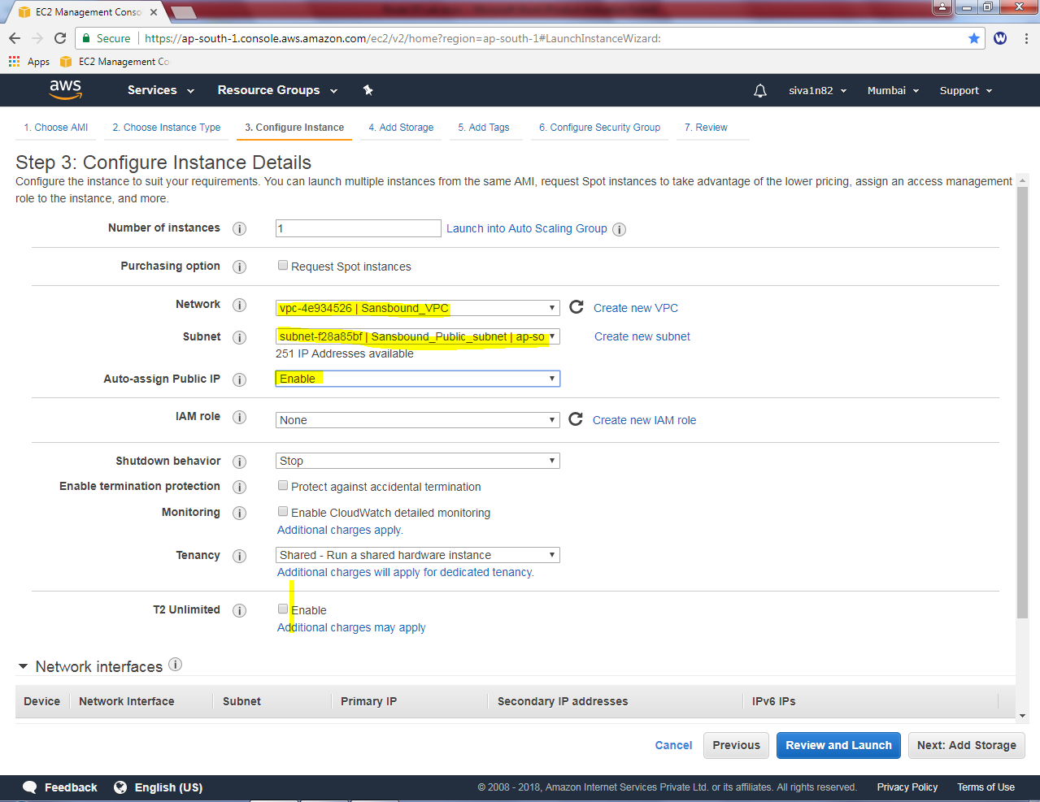

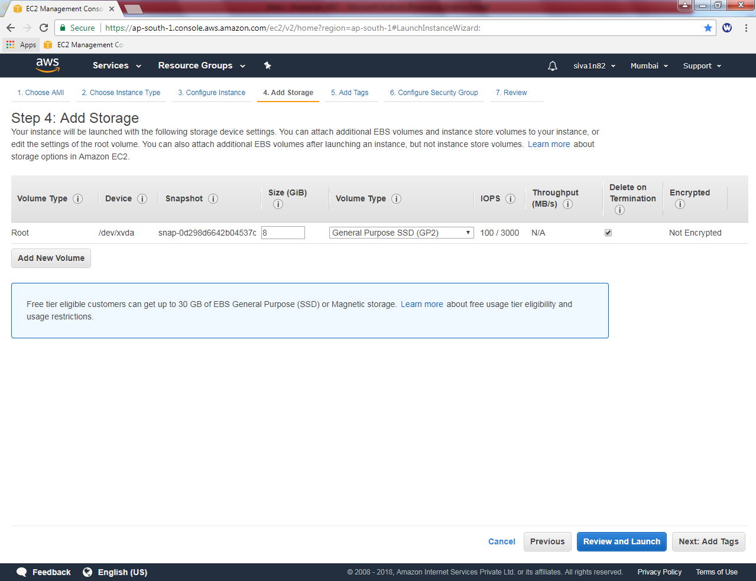

Click “Next”to continue.

Name: Linux web server

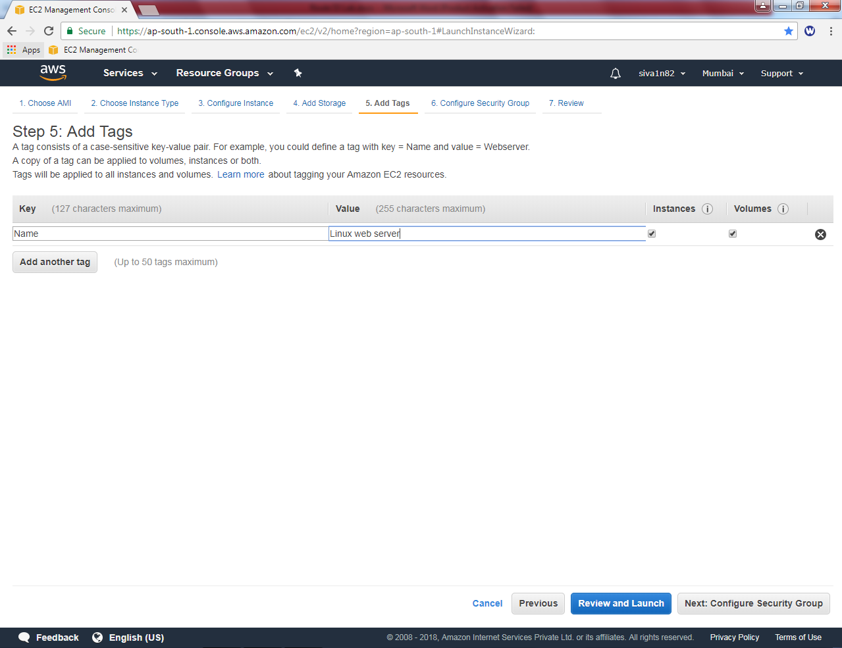

In Security group configure as Publc_Sec_Group.

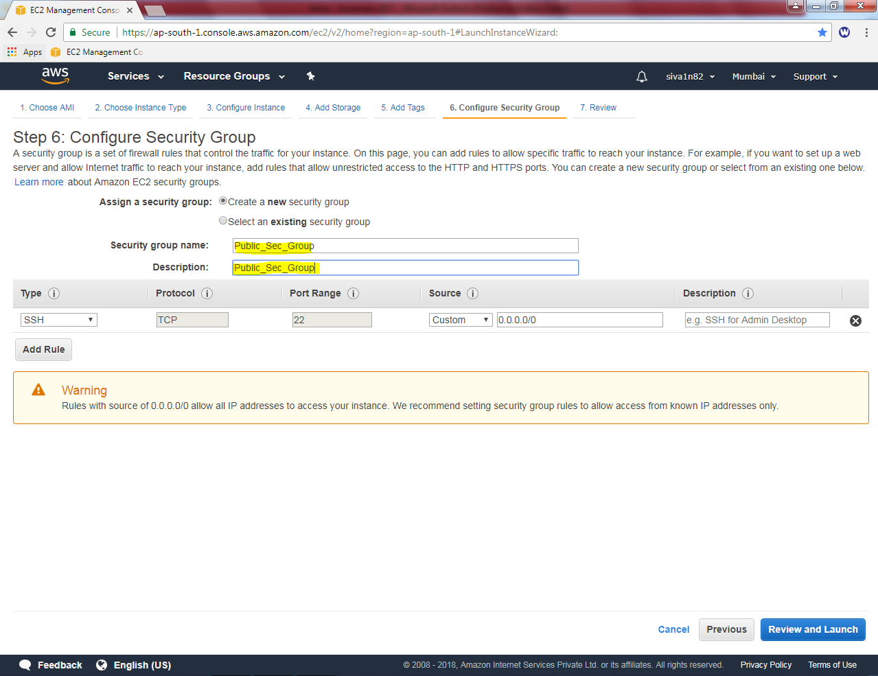

Click “Review and Launch”.

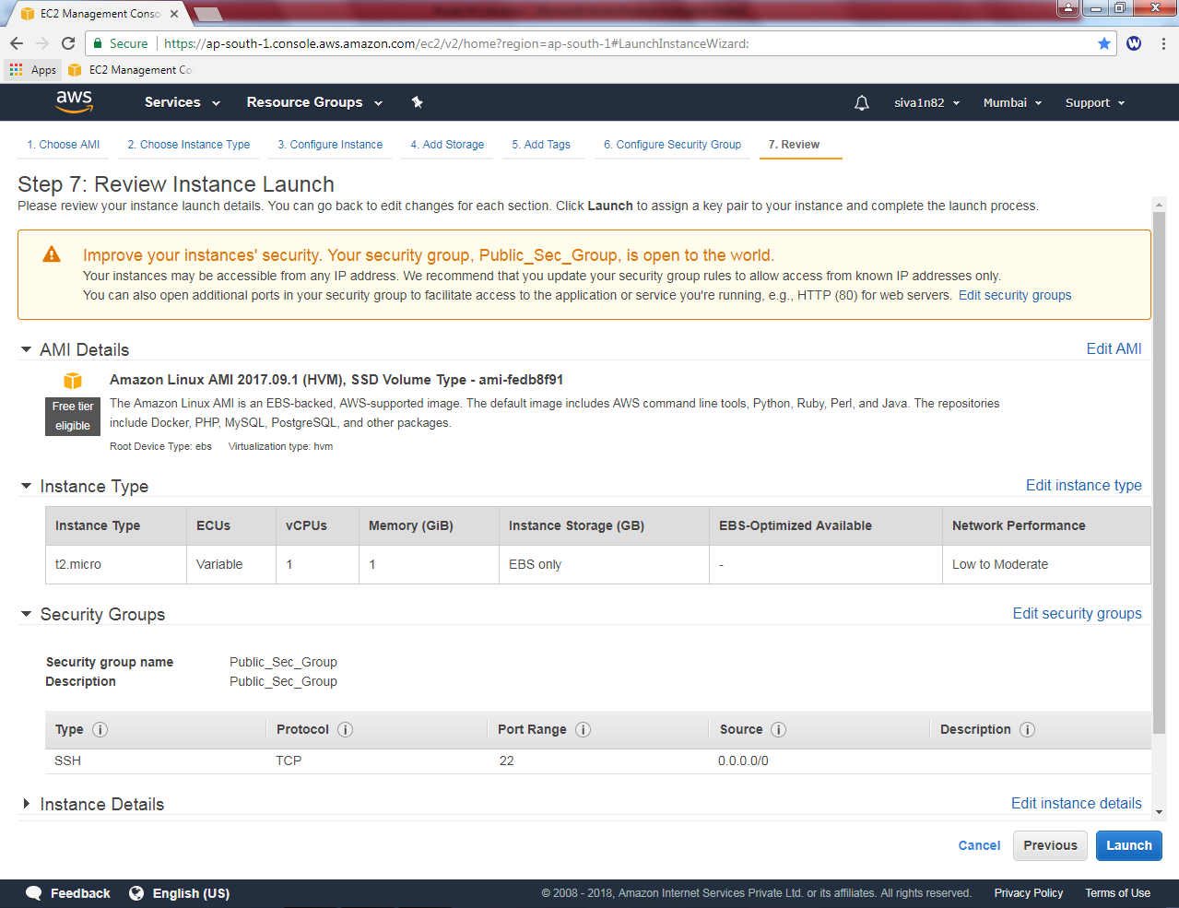

Then click “Launch”.

Select existing key pair, and check “I acknowledge”.

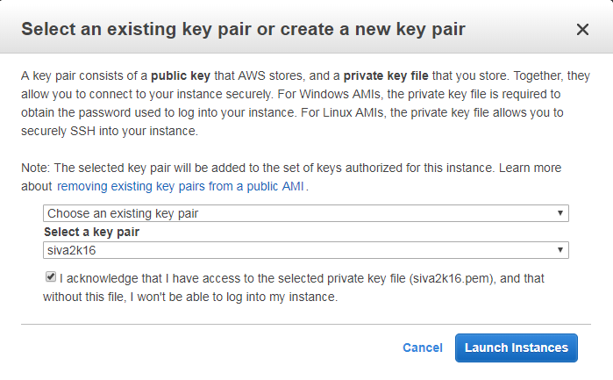

Click “Launch instances”.

Click “Launch instance to create windows instance”.

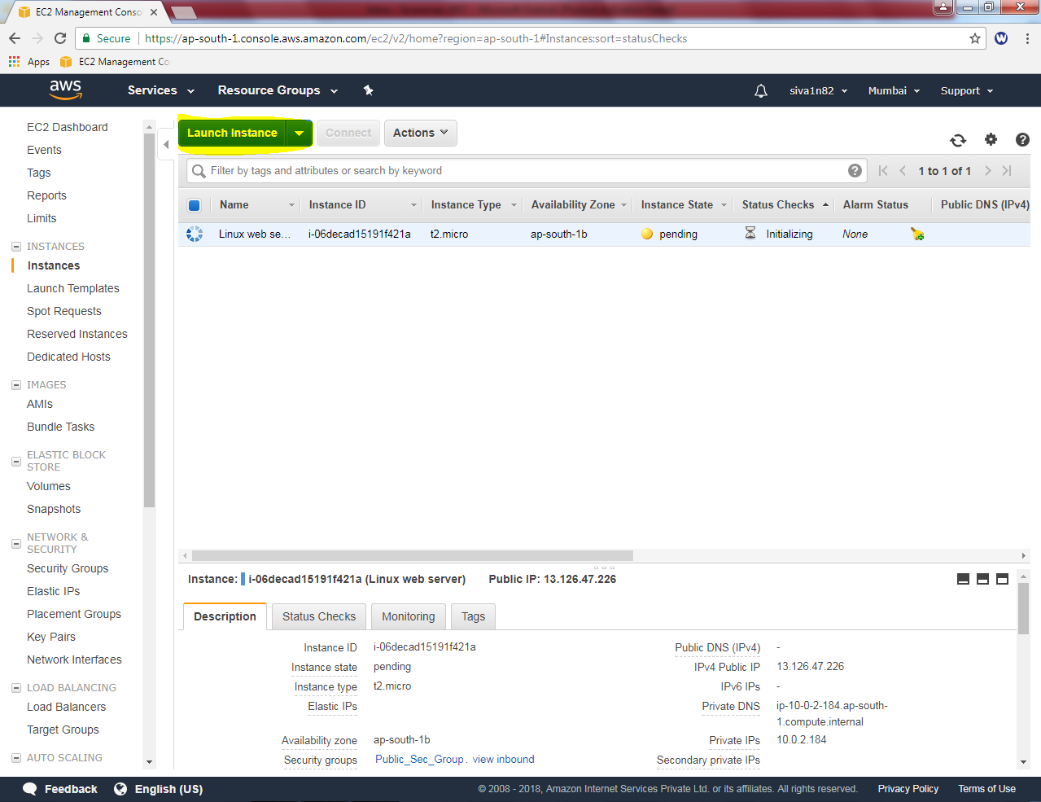

Select “Windows Server 2016 Base”

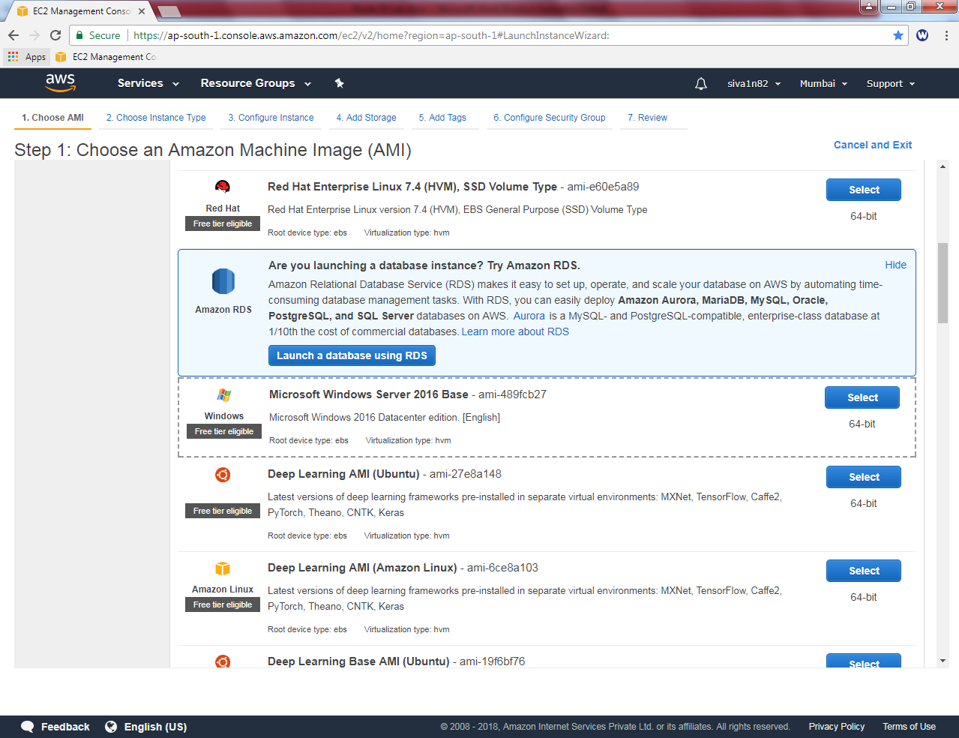

Select “t2.micro”

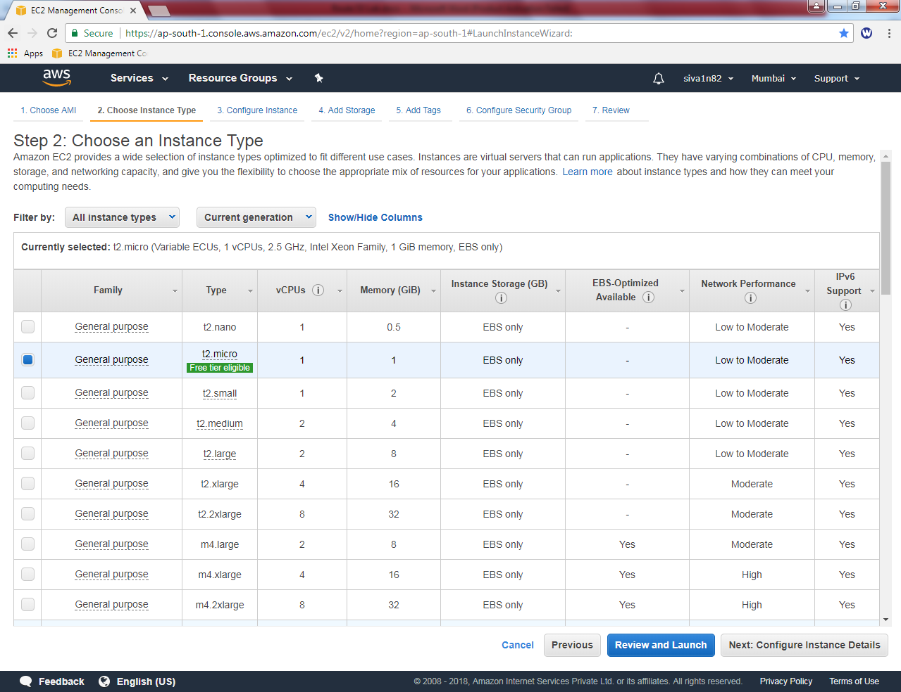

Click “Next”.

In Network “Sansbound_VPC”

In Subnet “Public Subnet”

Auto assign Public IP : Enable

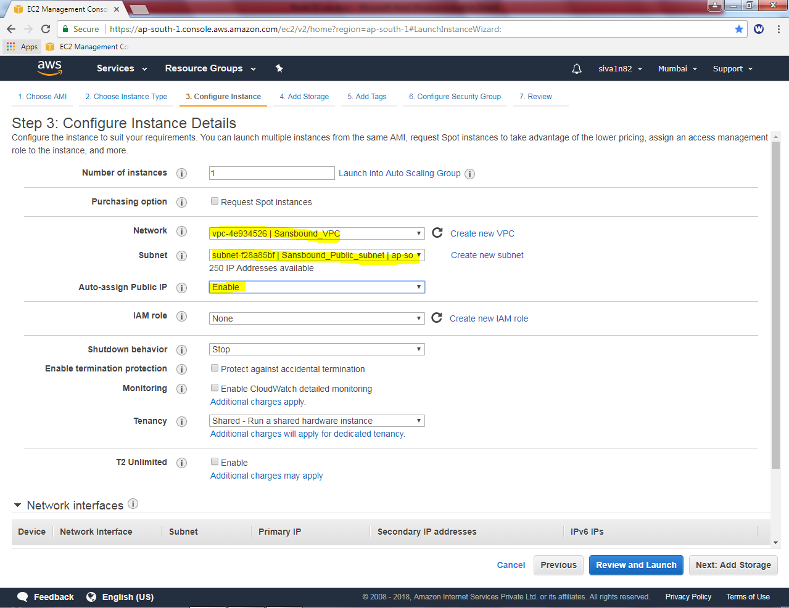

Click ”Next”.

Leave default settings and click “Next”.

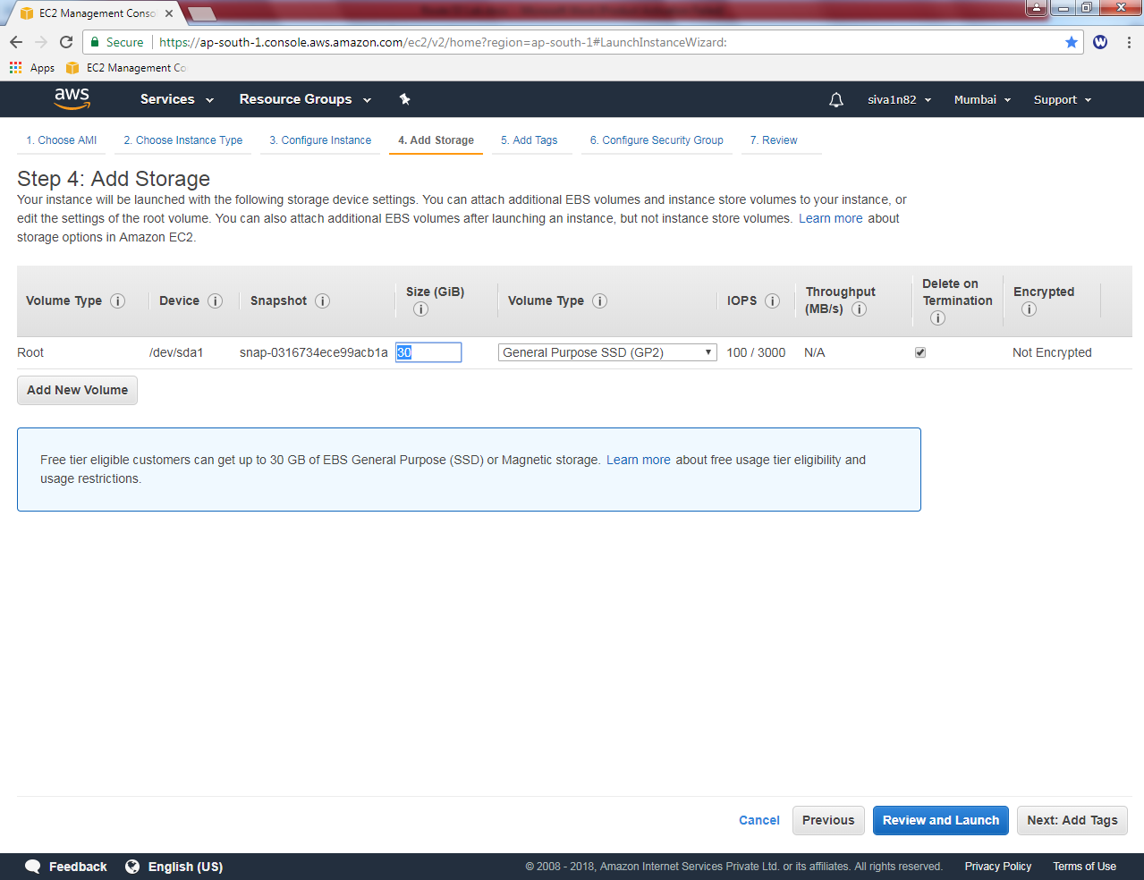

Name: Windows 2016 instance

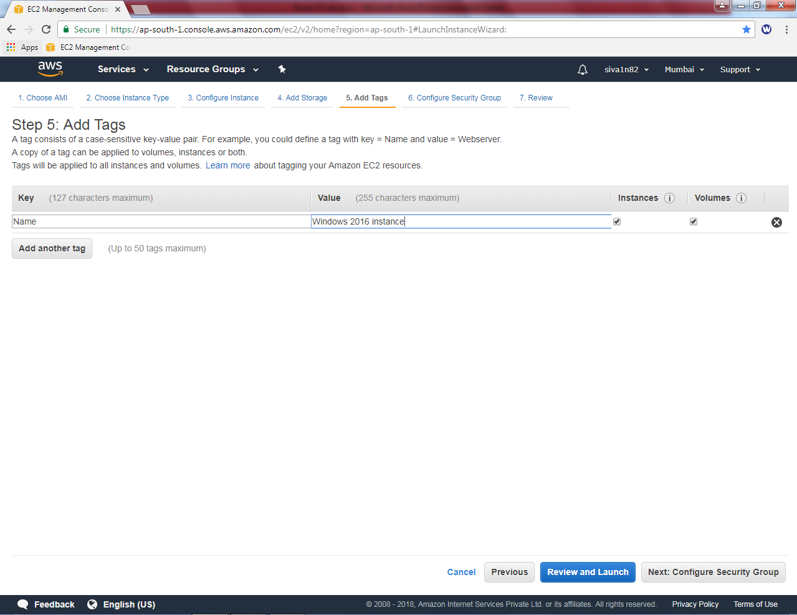

Click “Next”.

In Security group, new security group for windows as “Public_Sec_Group_Windows”.

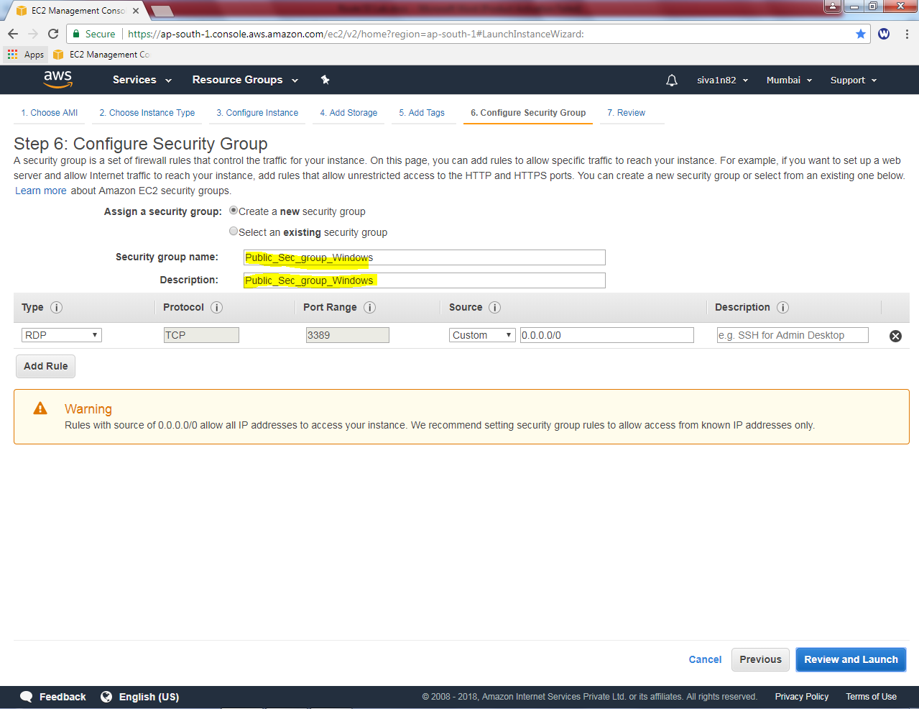

Click “Review and Launch”.

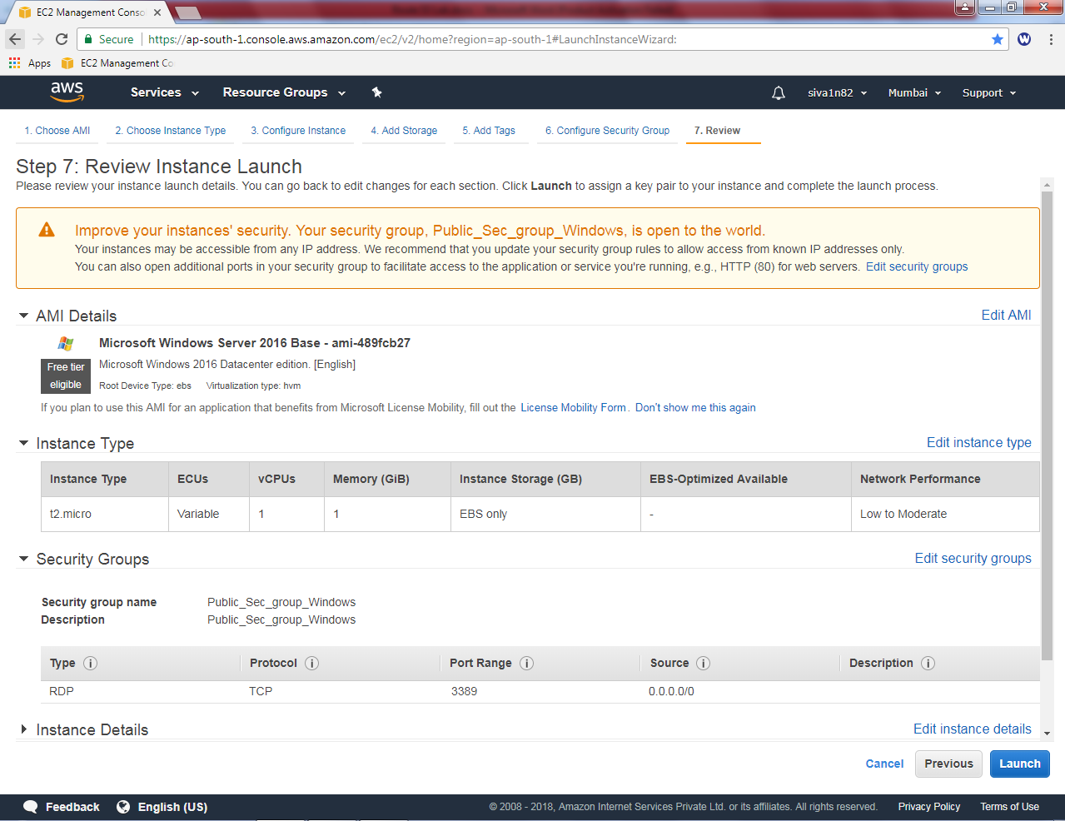

Click Launch.

Choose the existing key pair and then click “I acknowledge”check box.

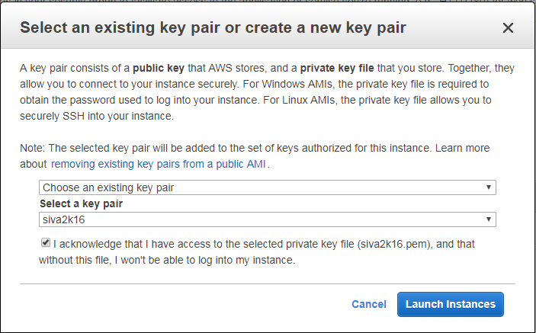

Then click Launch Instances.

Get the IP address of Linux machine: 13.126.47.226

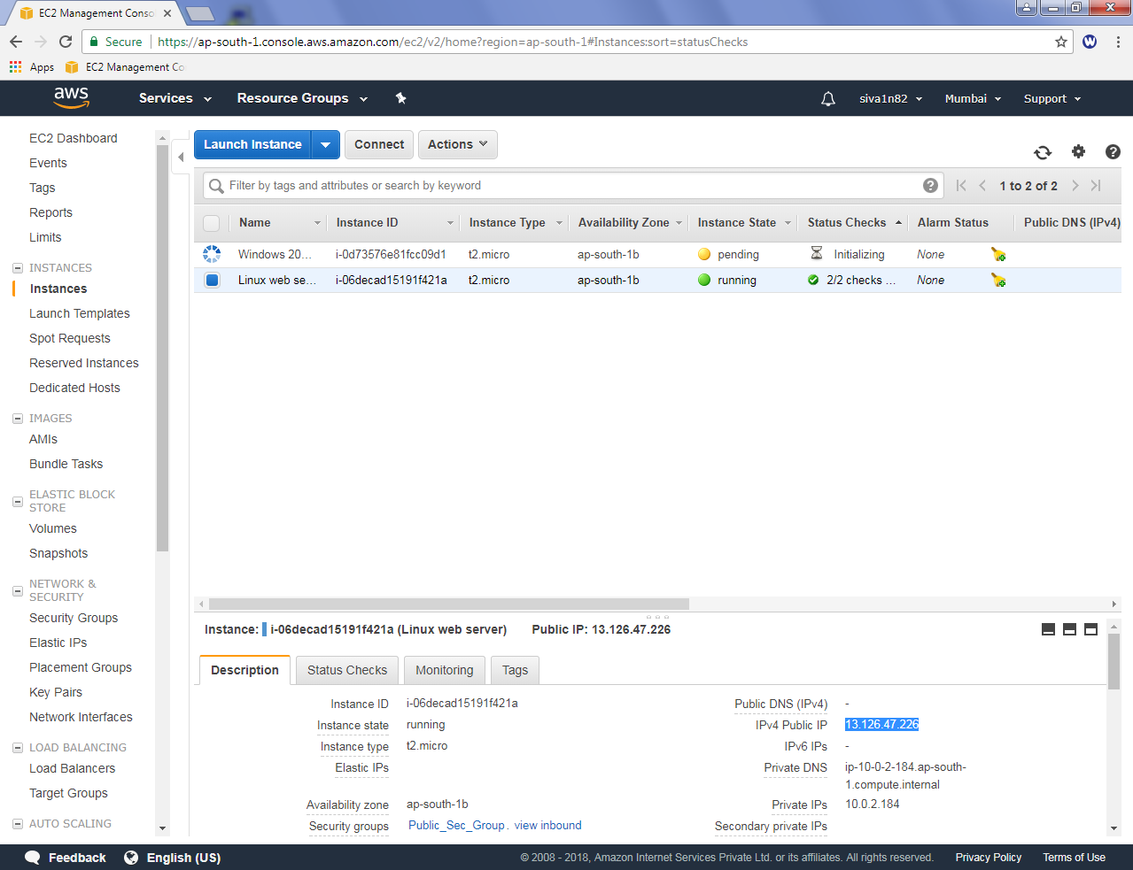.

Install putty generator on your local machine and then try to launch Putty key generator.

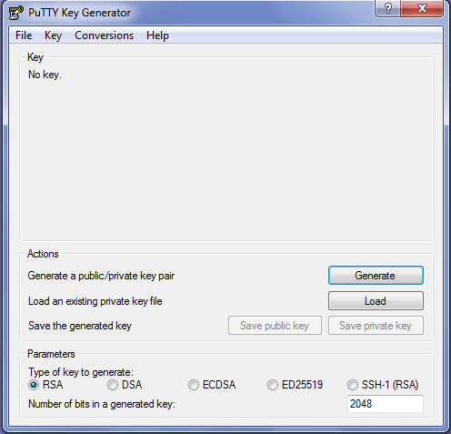

In File, click “Load private key”.

Select the path of *.Pem file to decrypt the private part of the key.

Select “All files” list.

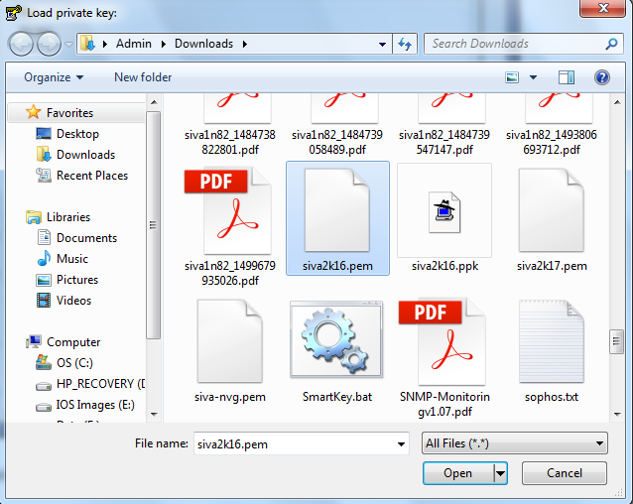

Then click “Open”.

Now you have successfully imported the key.

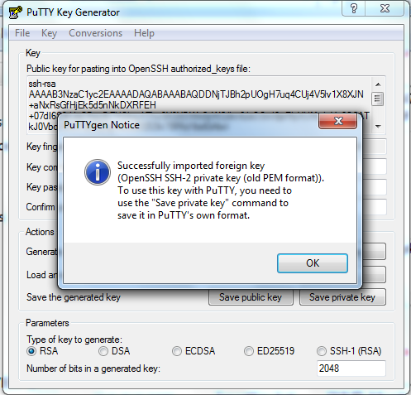

Click “Ok”.

Click “save Private key”

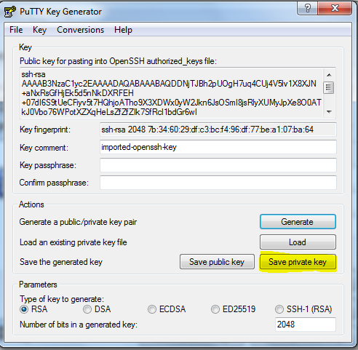

Then click “Yes”.

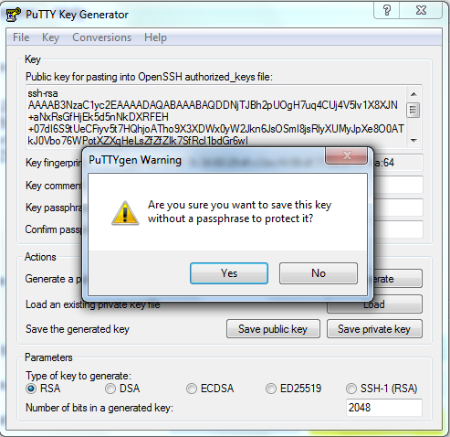

Select the path to store the “*.ppk” file.



Then click “save”.

Type host name and click “SSH”.

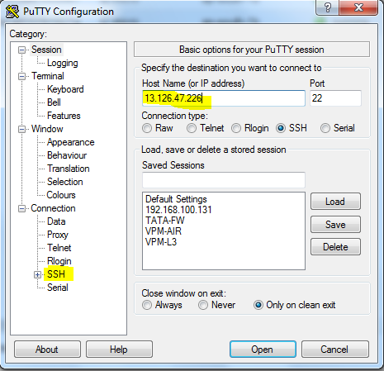

In SSH, expand the + symbol, then click “Auth”.

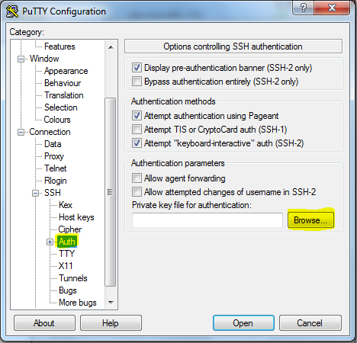

Browse the “*.ppk” file

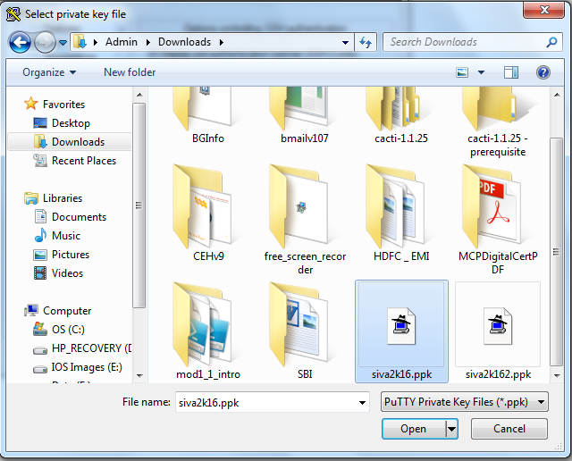

Click “Open”.

Click “Open”to launch the SSH application.

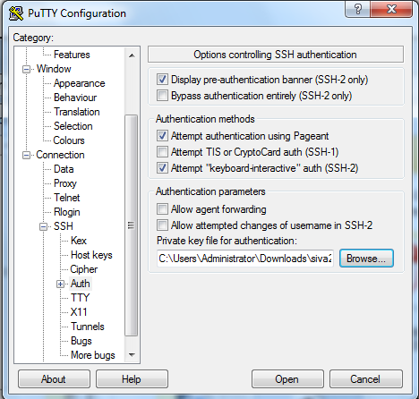

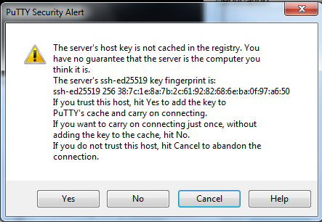

Click “Yes”.

Now try username for Linux AMI as **“ec2-user”**

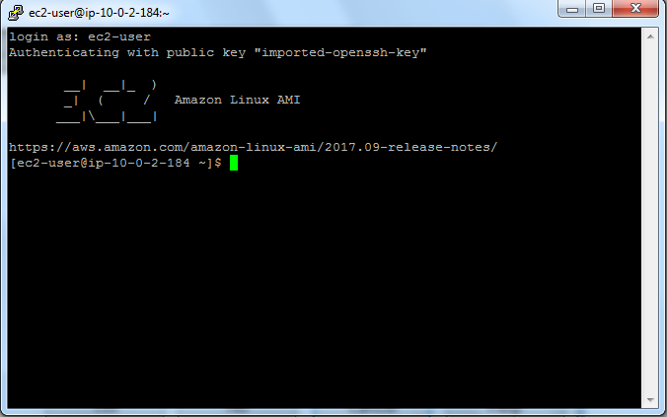

Now you can try to install the web server by using below mentioned command,

Command to install web server is as below.

***Yum install httpd***

Now you are unable to install the webserver because you need to login in with root / super user account.

Now type

***Sudo –i***

Then type the command as below

***Yum install httpd***

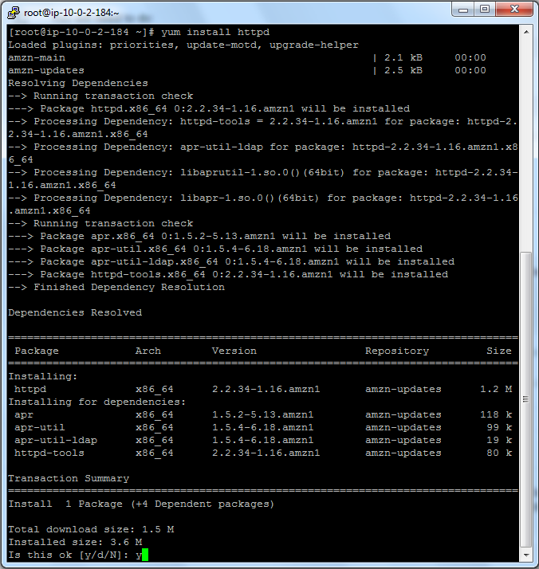

Type “Y”to install web server.

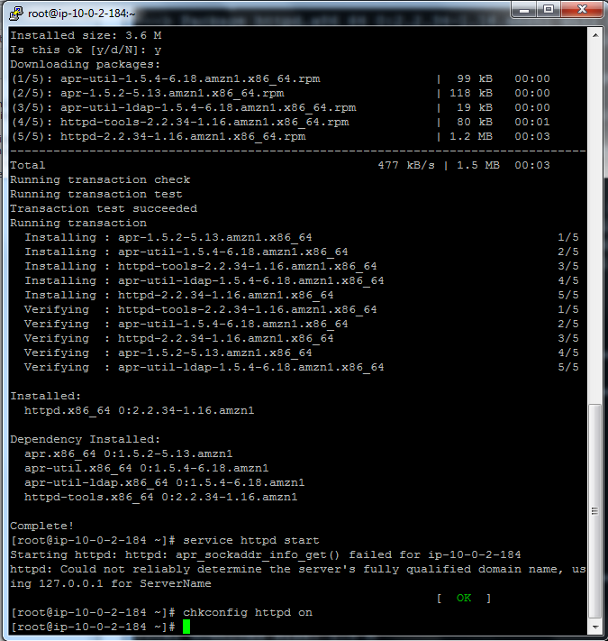

Then type below mentioned command in Linux ssh.

***Service httpd start***

***Chkconfig httpd on***

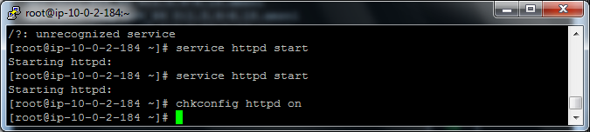

Now you have successfully installed the web server and service for the same has been started.

Now you can try to connect the webserver from Windows machine, you would not be able to connect. Because in Linux_public_sec_group Port 22 (SSH) only allowed in inbound rule.

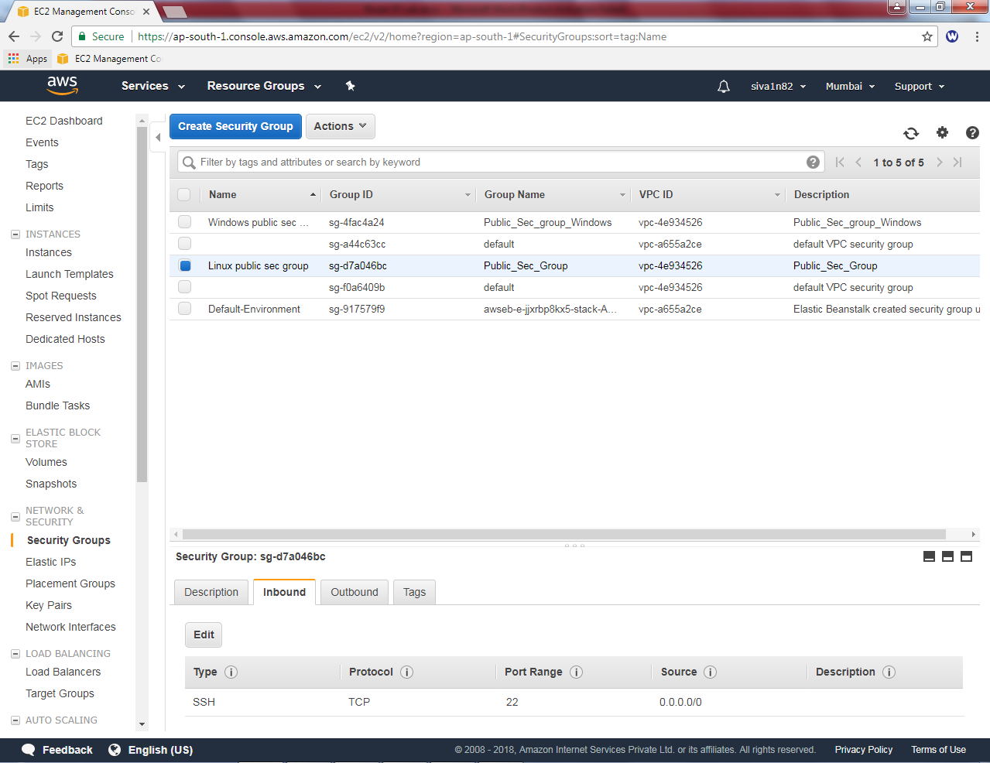

Hence you need to add port 80 in Linux_public_sec_group. Custom : 0.0.0.0/0

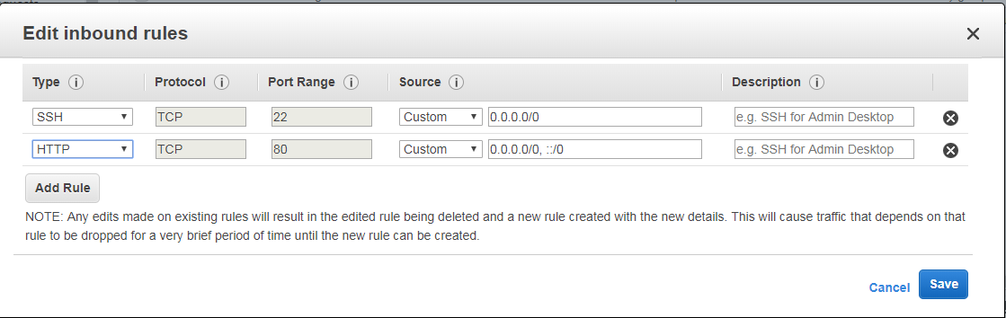

Then click “save”.

Now try to connect 10.0.2.184 host from windows machine. We have got the webserver page successfully.

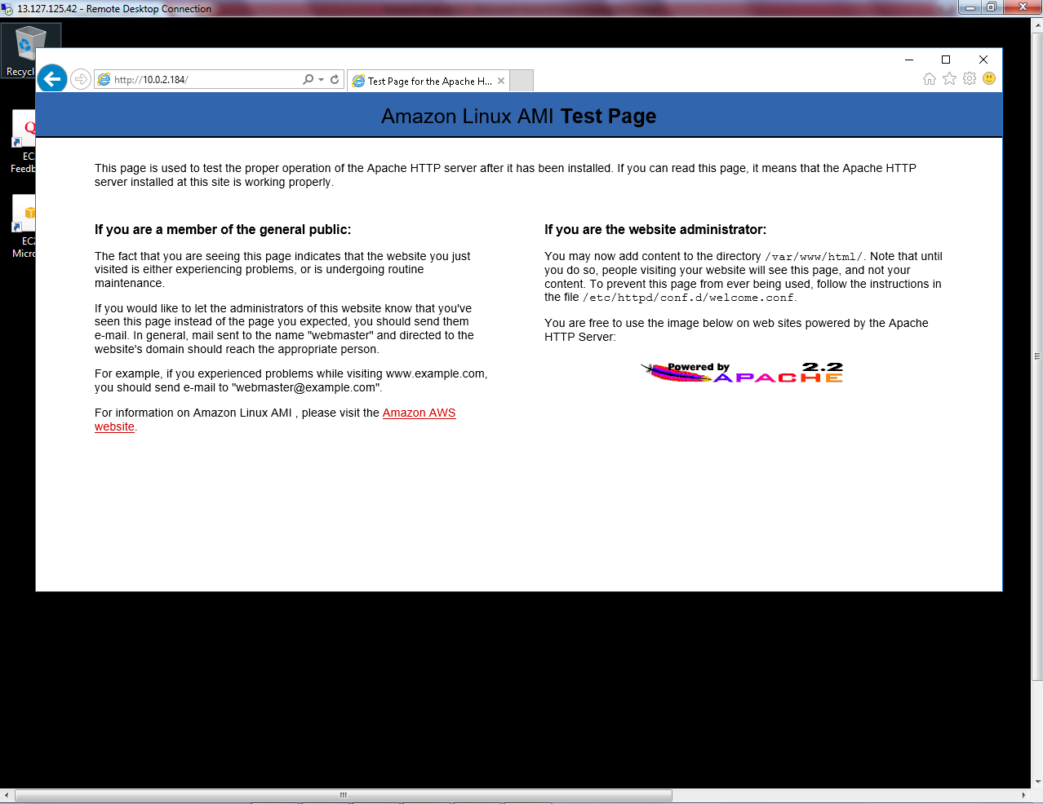

Now tried the web server from internet also that’s working fine with IP address.

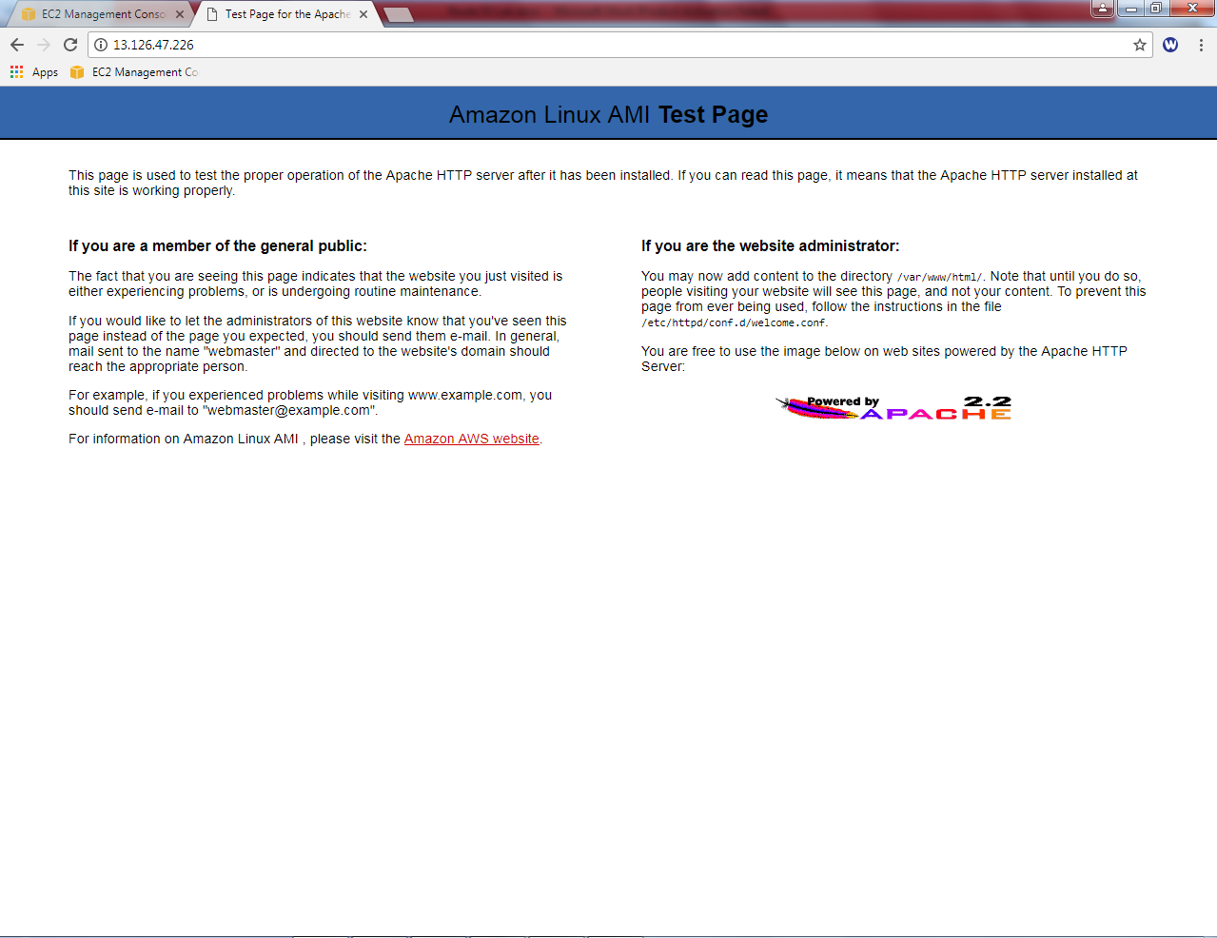

Our Scope is we need to connect the webserver by using Fully Qualified Domain Name (FQDN) from Windows 2016 machine by configuring Route 53. Now we need to configure Route 53.

Before going to configure Route 53, we need to ensure below mentioned settings in VPC.

In “Edit DNS Resolution”

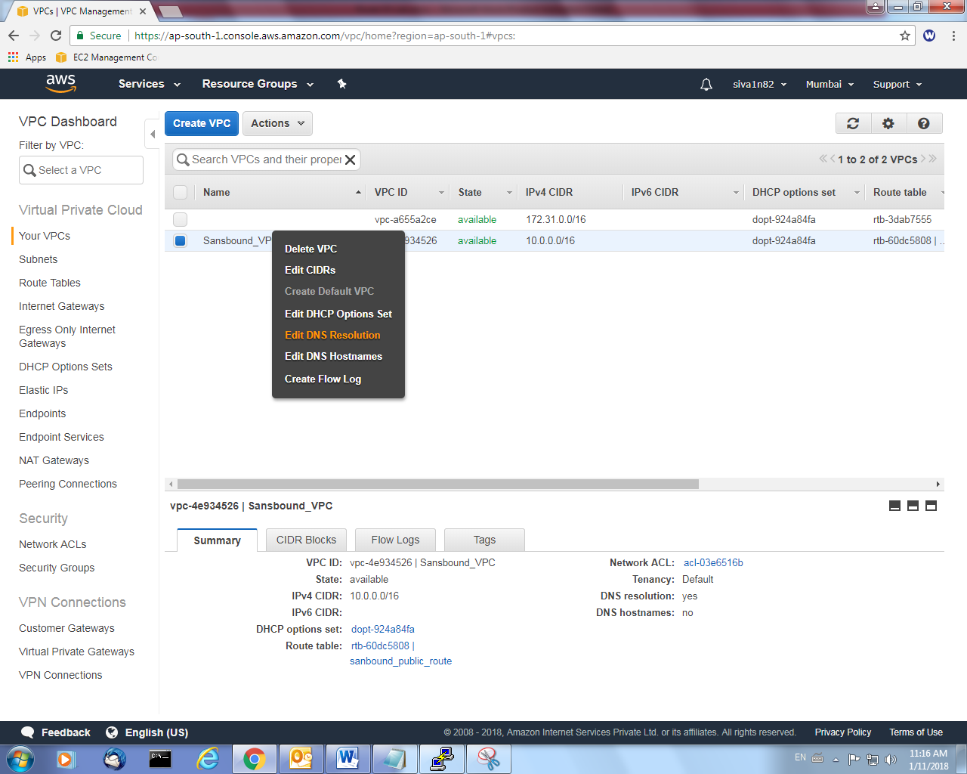

It should be “Yes”.

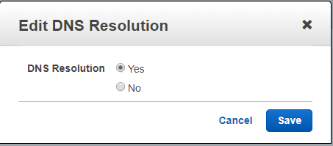

Before going to configure Route 53, we need to ensure below mentioned settings in VPC.

In “Edit DNS Hostnames”

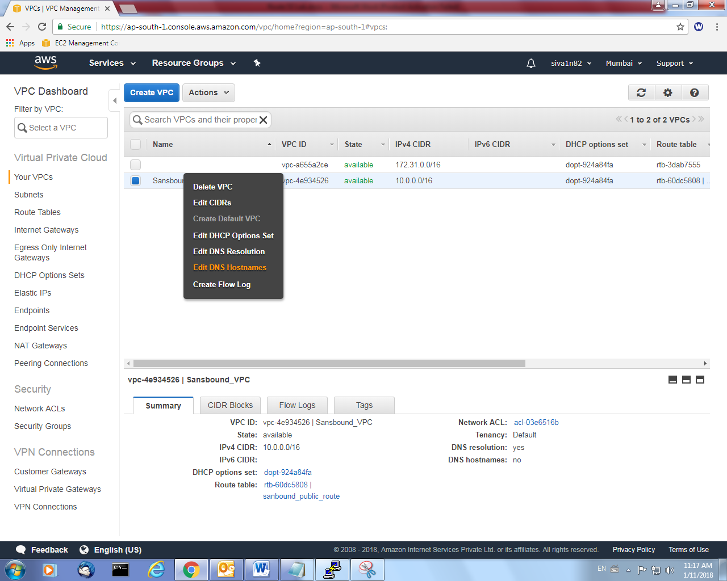

It should be “Yes”.

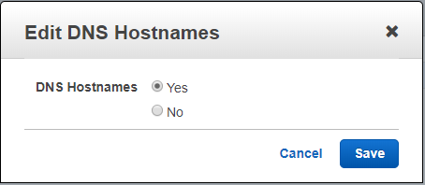

Goto Route 53,

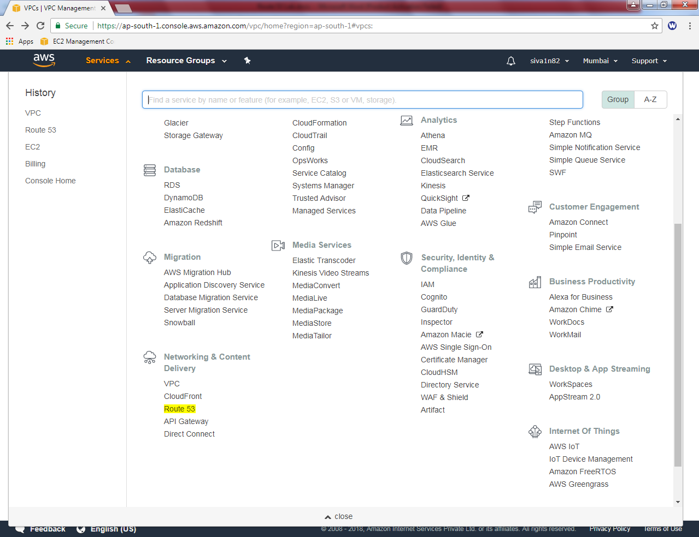

Click “DNS Management”

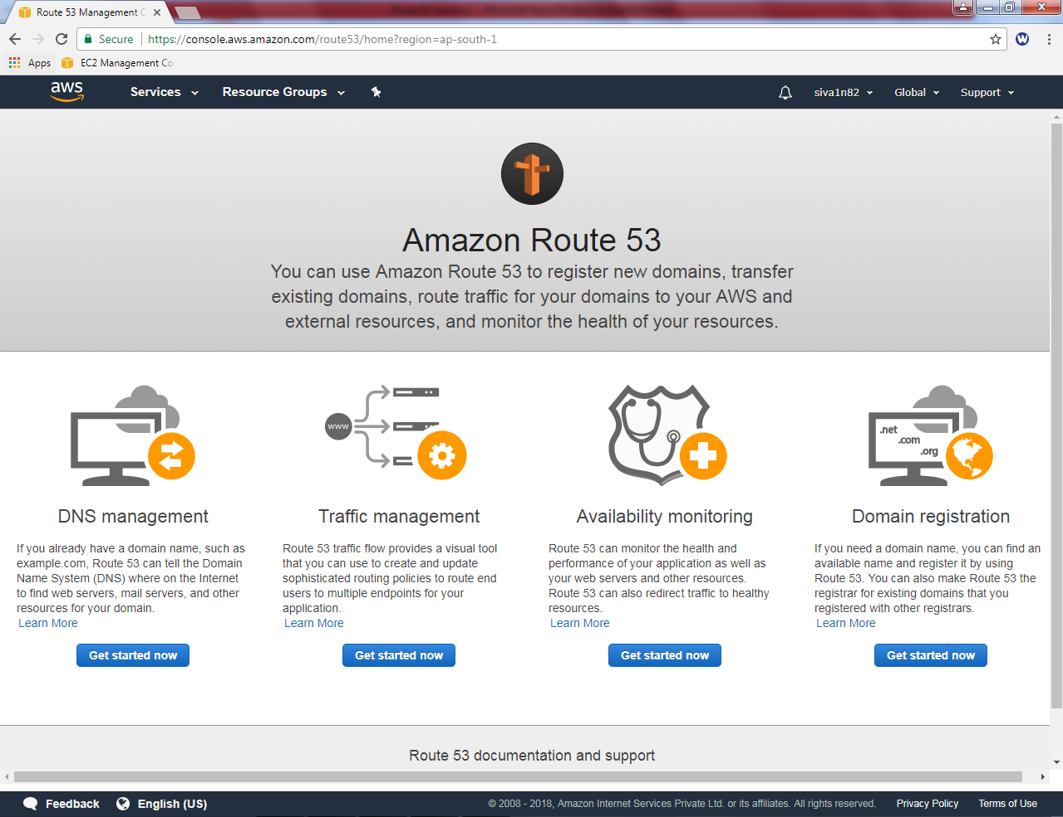

Click “Create Hosted Zone”.

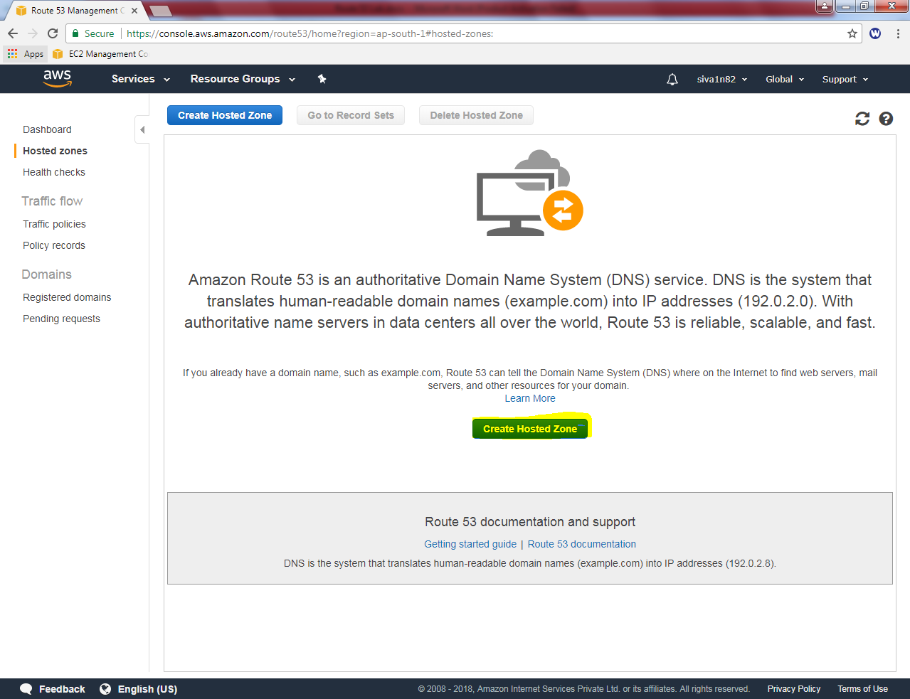

Click “Create Hosted Zone”.

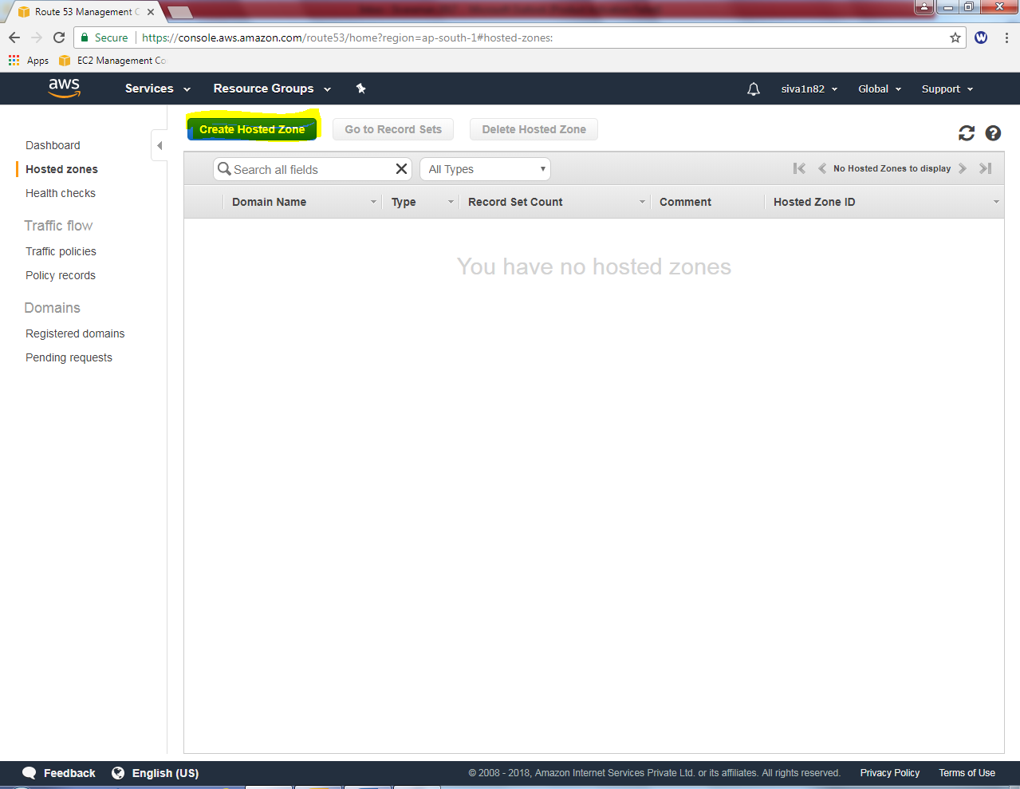

While creating Hosted Zone,

Domain name: sansbound.com

Comment: dns testing

Type: Private Hosted Zone for Amazon VPC

VPC ID: Mumbai

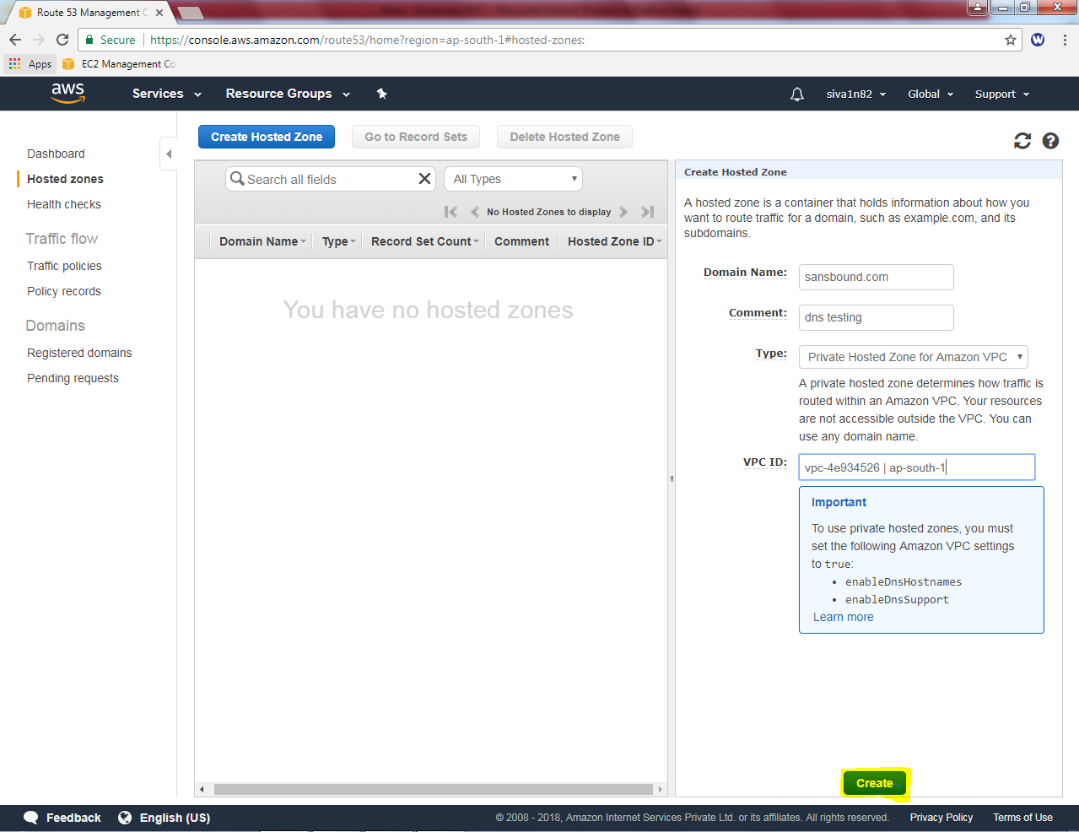

Then click “Yes, create”.

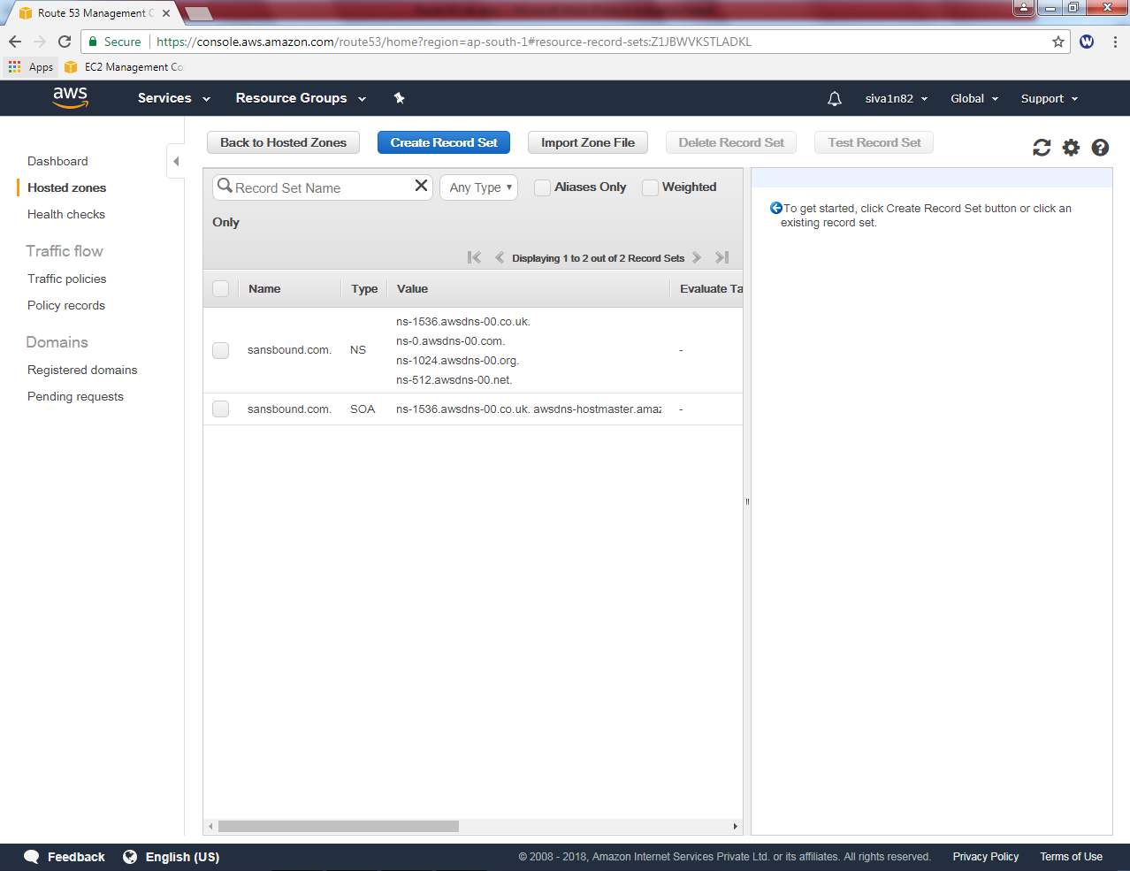

In sansbound.com server we have NS record and SOA record.

Select sansbund.com,

Then click “create record set”

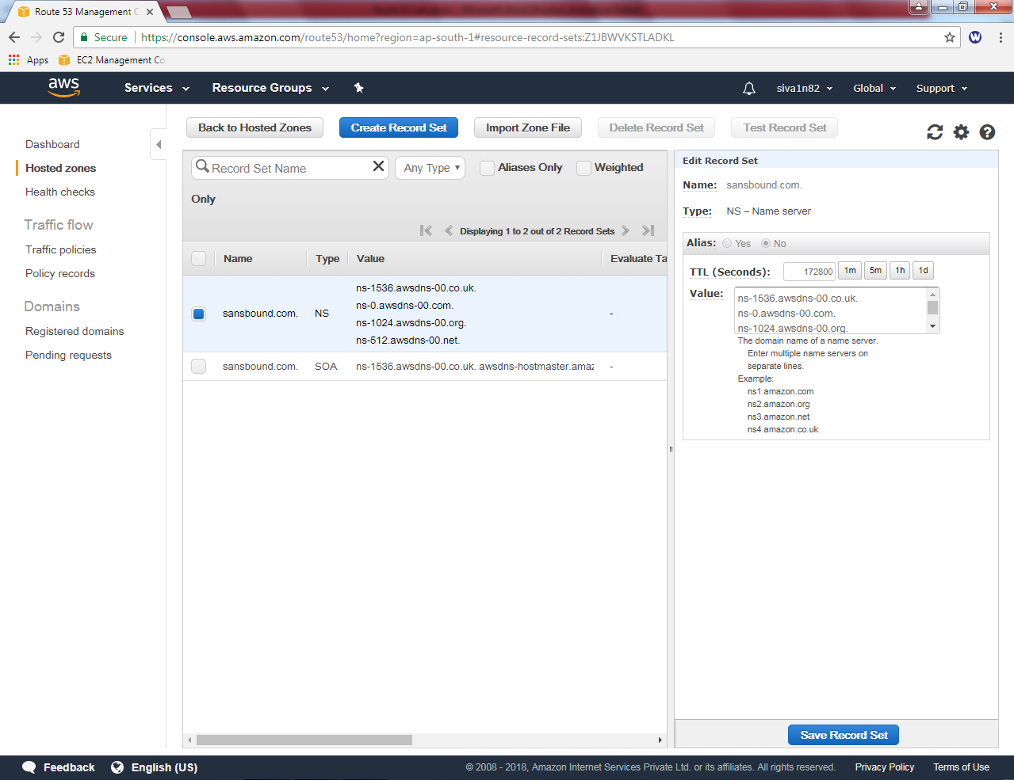

While creating record set,

Name: aws.sansbound.com

Type: A – IPV4 address

Value : (10.0.2.184) host machine

Route Policy : Simple

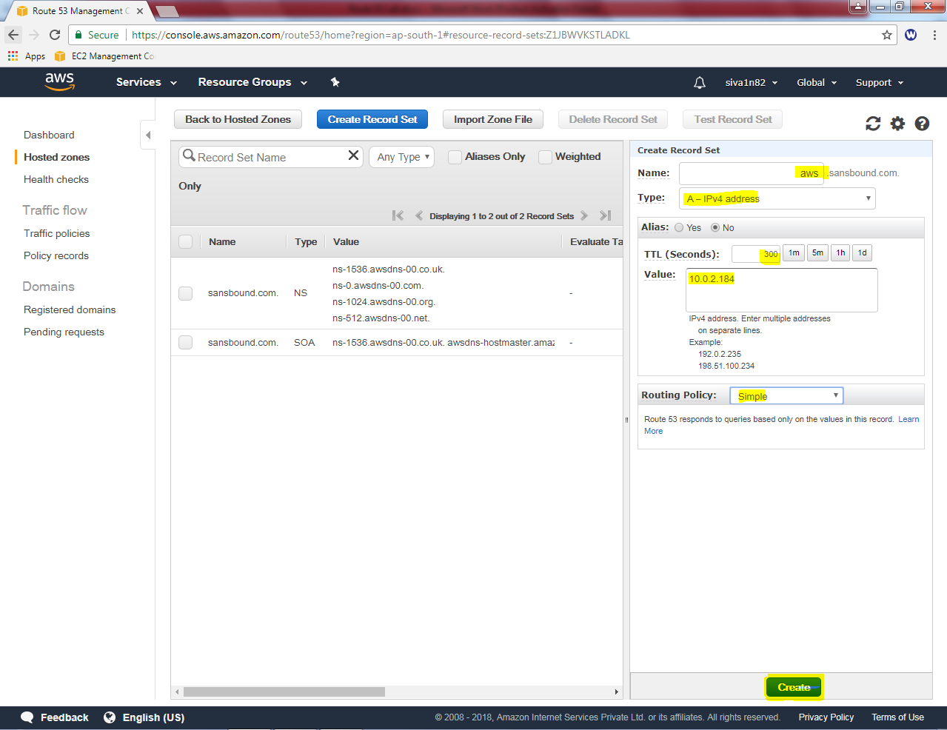

Then click “Create”.

We have created successfully A record for aws.sansbound.com.

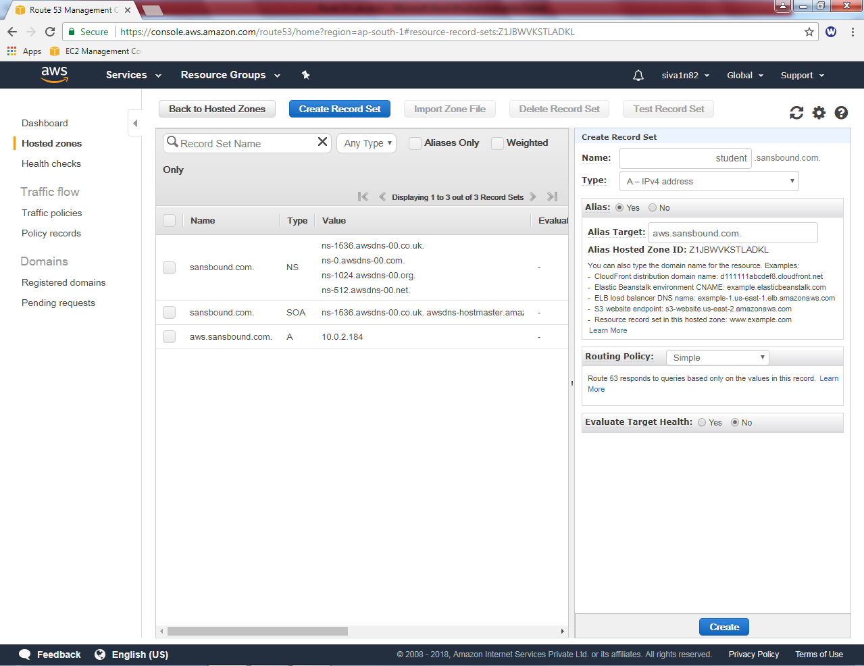

Now we can try to connect <http://aws.sansbound.com> from microsoft windows 2016 server. We have got the webserver successfully.

